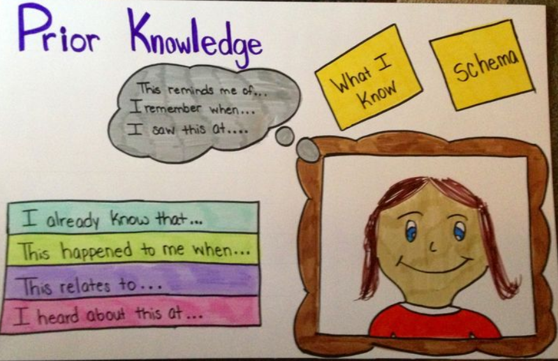

K-W-L Charts

Rationale
K-W-L charts are graphic organizers that help students organize information before, during, and after a unit or a lesson. They can be used to engage students in a new topic, activate prior knowledge, share unit objectives, and monitor students’ learning.

Procedure
- Make K-W-L Charts
Pass out the handout on the reverse side to students. Alternatively, you can distribute a blank sheet of paper and ask students to create their own chart.
- Complete Column 1
Have students respond to the first prompt in column 1: What do you Know about this topic? Students can do this individually or in small groups. Often, teachers create a master list of all students’ responses. One question that frequently emerges for teachers is how to address misconceptions students share. Sometimes it is appropriate to correct false information at this point in the process. Other times, you might want to leave the misconceptions so that students can correct them on their own as they learn new material.
- Complete Column 2
Have students respond to the prompt in column 2: What do you Want to know about this topic? Some students may not know where to begin if they don't have much background knowledge on the topic. Therefore, it can be helpful to put the six questions of journalism on the board as prompts (Who? What? Where? When? Why? How?). We suggest that students’ responses and questions be used to direct the course of study. As students share what they want to learn, this step provides an opportunity for teachers to present what they hope students will learn in the unit.
- Complete Column 3 and Review Columns 1 and 2
Throughout the unit, students can review their K-W-L charts by adding to column 3: What did you Learn? Some teachers have students add to their charts at the end of each lesson, while others have students add to their charts at the end of the week or the end of the unit. As students record what they have learned, they can review the questions in column 2, checking off any questions that they can now answer. They can also add new questions. Students should also review Column 1 so they can identify any misconceptions they may have held before beginning the unit.

Source:
Facing history and ourselves. Resource library and teaching strategies. Retrieved
February 7, 2019 from https://www.facinghistory.org/resource-library/teaching-
strategies/k-w-l-charts
www.facinghistory.org

K-W-L Chart
Assess what you know about a particular topic before and after you have engaged with it. Fill the the columns below with what you Know about the topic, what you Want to know, and what you’ve Learned.

What do you Know about the topic? | What do you Want to know? | What did you learn?

Examples of questions for prior knowledge self-assessments

Example 1:

Please circle the letter that best represents your current knowledge:
Federalism
a. Have never heard of this
b. Have heard of it, but don’t really know what it means
c. Have some idea what this means, but not too clear
d. Have a clear idea what this means, and can explain it

Example 2: (perhaps for a prof/tech class):

Have you designed or built a digtal logic circuit?
a. I have neither designed nor built one.
b. I have designed one, but not built one.
c. I have built one, but not designed one.
d. I have both designed and built one.

Example 3:

For each of the following Shakespearean plays, place a check mark in the cell if it describes your experience.
Play | Have Read it | Have seen a live performance | Have seen a TV or movie production | Have written a college-level paper on it
Hamlet
King Lear
Henry IV
Othello

Source:

Angelo, T.A., & Cross, K.P. (1993). Classroom Assessment Techniques. San Francisco: Jossey-Bass.

Carnegie-Mellon University. Prior knowledge self-assessments. Retrieved February 1, 2019
from https://www.cmu.edu/teaching/assessment/priorknowledge/selfassessments.html

