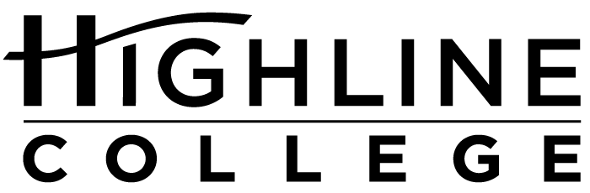

MEDIA RELEASE

FOR RELEASE: Immediately

DATE: January 12, 2017

CONTACT: Carolyn Sinay: (206) 592-3588, csinay@highline.edu
Kari Coglon Cantey: (206) 291-8622, kcantey@highline.edu

Help Is Here at Tax Time
Free income tax preparation available at Highline College
DES MOINES, Wash. — Community members can get their taxes done for free, thanks to a partnership between United Way of King County and Highline College. Households that make less than $64,000 are eligible, as long as tax returns do not involve business taxes, rental income, or sale of property or stocks.

This community service is available now through April 20 on Wednesdays and Thursdays from 4 to 8 p.m. and Saturdays from 10 a.m. to 2 p.m. in the Highline College Outreach Center (located at 23835 Pacific Highway S., Kent, Wash.), Building 99, Room 251.

Participants will need to bring the following:
— Social Security cards/individual tax identification numbers (ITINs) and birthdates for everyone who will be listed on the return.
— Photo ID.
— All tax statements, such as W-2 forms, 1099 forms and SSA-1099 forms.

Bringing bank account numbers, routing numbers and a copy of last year’s tax return is also highly recommended. Those participants filing returns with spouses must both be present to e-file.

No appointment is necessary. Those who arrive first will be served first. Services are provided by IRS-certified volunteers.

In addition to tax preparation, community members can sign up for health care and public benefits and access free credit reports.

For questions or more information, visit https://www.uwkc.org/need-help/tax-help/, email freetax@uwkc.org or call 800-621-4636.

# # #

Celebrating its 55th anniversary, Highline College was founded in 1961 as the first community college in King County. With nearly 17,000 annual students and 350,000 alumni, it is one of the state’s largest institutions of higher education. The college offers a wide range of academic transfer, professional-technical education and applied bachelor’s degree programs. Alumni include former Seattle Mayor Norm Rice, entrepreneur Junki Yoshida and former Washington state poet laureate Sam Green.

