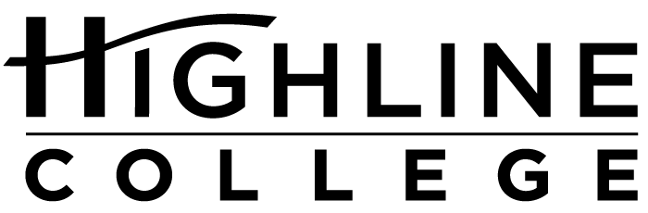

CALENDAR ITEM

FOR RELEASE: Immediately
DATE: January 14, 2016
CONTACT: Linda Faaren: (206) 592-3670, lfaaren@highline.edu
Kari Coglon Cantey: (206) 291-8622, kcantey@highline.edu
Dr. Lisa Skari: (206) 870-3705, lskari@highline.edu
Preparing for US citizenship
Highline College will offer free course

Course: Preparing for the U.S. Citizenship Test

Dates: Participants can choose from two class sessions:
— Mondays and Wednesdays, January 20–March 23, 2016; 1–2:50 p.m.
— Saturdays, January 23–March 26, 2016; 1–3 p.m.

Price: Free, but space is limited

Location: Highline College’s main campus; Building 19, room 102

Highline College’s main campus is located midway between Seattle and Tacoma at South 240th Street and Pacific Highway South (Highway 99); address: 2400 S. 240th St., Des Moines, Wash.

Description: Highline College will be offering a free course for community members who are preparing to take the U.S. Citizenship Test. Students will be taught by an instructor who is trained in the content and who has significant teaching experience with English language learners. There will be assistance with test preparation, application procedures and follow-through on the steps to becoming a U.S. citizen. Students must bring their permanent resident card and their driver’s license or identification card. Each of the two class sessions has open enrollment, and students may register throughout the quarter. Students may also qualify for a waiver of the fee to take the citizenship test. Help is available to apply for the fee waiver.

Sponsored by: Highline College and Asian Counseling Referral Services

For more information: Linda Faaren: (206) 592-3670, lfaaren@highline.edu

# # #

Highline College was founded in 1961 as the first community college in King County. With nearly 17,000 annual students and 350,000 alumni, it is one of the state’s largest institutions of higher education. The college offers a wide range of academic transfer, professional-technical education and bachelor’s degree programs. Alumni include former Seattle Mayor Norm Rice, entrepreneur Junki Yoshida and former Washington state poet laureate Sam Green.

