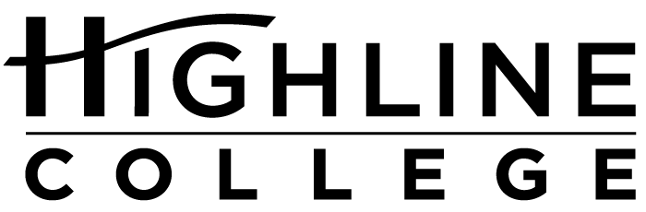

MEDIA RELEASE

FOR RELEASE: Immediately
DATE: January 21, 2016
CONTACT: Chantal L. Carrancho: (206) 592-4026; ccarrancho@highline.edu
Kari Coglon Cantey: (206) 291-8622, kcantey@highline.edu
Dr. Lisa Skari: (206) 870-3705, lskari@highline.edu
College Bound in the Fall?
Applying for financial aid is critical step, and free event will help

DES MOINES, Wash. — Now is the time for college-bound students—including qualifying immigrants—to apply for financial aid. A free event on January 30, 2016, at Highline College will help students and their families apply for financial aid. To encourage participation, attendees will be entered into a raffle to win scholarships, thanks to a $1,500 donation from the Highline College Foundation.
Experts and trained volunteers will be on hand to help people with financial aid and college applications. Participants should arrive at noon in Building 7 on Highline’s main campus for a short presentation about how to pay for college and common questions about financial aid.
After the presentation, participants will go to the college’s computer lab to complete the online financial aid applications. People who are U.S. citizens or eligible non-citizens can file the Free Application for Federal Student Aid (FAFSA). People unable to file the FAFSA due to immigration status, can file the Washington Application for State Financial Aid (WASFA). Both applications are now open. The priority deadline for state financial aid programs, which include the State Need Grant and College Bound Scholarship, is February 1.
Highline’s Financial Aid staff and trained volunteers will be available to help with the online applications, meet individually with participants and answer questions until 4 p.m.
This community event is open to anyone interested in continuing education beyond high school, and is made possible through College Goal Washington. Similar events will be happening throughout January and February at other locations. View an up-to-date list of College Goal Washington event dates and locations on ReadySetGrad.org.
College Goal Washington is an initiative to increase educational attainment in Washington state. The support provided at these events makes financial aid programs more accessible to students who are low-income, first-generation, or underrepresented in postsecondary education. Filing an application for financial aid is an important step in the college application process, and there is a strong correlation between applying for financial aid and enrolling in college.
The Washington Student Achievement Council administers College Goal Washington through the 12th Year Campaign. College Goal Washington is also part of the nationwide College Goal Sunday Initiative, supported by the National College Access Network (NCAN).
# # #

Highline College was founded in 1961 as the first community college in King County. With nearly 17,000 annual students and 350,000 alumni, it is one of the state’s largest institutions of higher education. The college offers a wide range of academic transfer, professional-technical education and bachelor’s degree programs. Alumni include former Seattle Mayor Norm Rice, entrepreneur Junki Yoshida and former Washington state poet laureate Sam Green.

