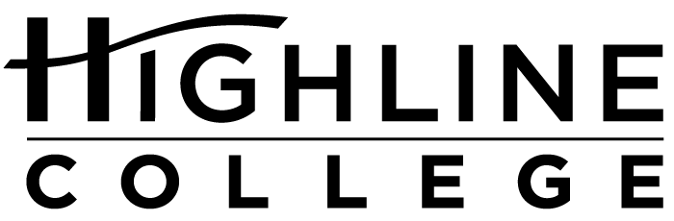

MEDIA RELEASE

FOR RELEASE: Immediately

DATE: February 9, 2017

CONTACT: Joshua Magallanes: (206) 592-3998, jmagallanes@highline.edu
Kari Coglon Cantey: (206) 291-8622, kcantey@highline.edu

Highline College to Host Free Summit for Latino Students

New Format, New Name for 3rd Annual Summit, Feb. 25

DES MOINES, Wash. — High school students in south King County are invited to Highline College for the 2017 Latinx Summit. The daylong event is designed to provide students with the tools they need for success in higher education and beyond. The summit is scheduled for Feb. 25, 2017, 8 a.m.−3 p.m., in Building 2 on the college’s main campus.

It is free and open to all, but registration is required at highline.edu/latinx-summit-2017.

Approximately 100 high school students are expected to attend. Event organizers hope to empower Latino/a youth to embrace higher education and knowledge while celebrating their cultural heritage and background.

The summit will include a keynote address by immigrant and storyteller Luis Ortega, workshops, lunch and a closing session with raffle prizes. Guest speakers, including educators from Highline College, will share with attendees their professional and personal experiences.

Artist and newly minted Highline alumna Samantha Montes de Oca contributed her time and talent to this year’s Latinx Summit by creating the artwork and materials promoting the event.

Originally from Caracas, Venezuela, and now living in Kent, Montes de Oca said she researched the culture of each Latin country and looked at pictures to find inspiration for the artwork.

“I wanted to create something that represents each and every one of us and the fact that we are present all around the world. We have a lot of similarities such as the use of bright colors, music, patterns, styles, etc. Still, each country has its own identity,” said Montes de Oca, who is proud of her Latin American heritage.

She used a number of symbols to represent each country, such as the sugar skull for Mexico, penguins and yerba mate for Argentina, and the mask for carnivals in Brazil.

The 23-year-old’s artistic talent has been recognized on a number of occasions at Highline, including the college’s recent film contest where she collaborated with fellow alumna Lisa Lopez to take third place for the animated film “Home Is Where the Heart Is,” which can be viewed at https://youtu.be/dRrEZ80jcBA.

In spring of 2016, she earned the award for outstanding program contribution as a member of the college’s Center for Leadership and Service (CLS) design team.

To see more of her work, visit her online portfolio at https://www.behance.net/samycm2.

Now in its third year, the summit has undergone a format and name change. Previously held on two consecutive mornings and named Latin@ Summit, the event will now run one full day and is called the Latinx Summit. Organizers are using the term Latinx as a gender-neutral alternative to Latino and Latina, hoping to stress the inclusive nature of the summit.

Highline serves the most diverse community in the state, which is mirrored in its student population that includes more than 70 percent students of color, 17 percent of whom are Hispanic/Latino.

For more information and to register, visit highline.edu/latinx-summit-2017 or contact Joshua Magallanes at (206) 592-3998 or jmagallanes@highline.edu.

Highline’s main campus is located midway between Seattle and Tacoma at South 240th Street and Pacific Highway South (Highway 99).

# # #

Attachments (2):
1: Artist Samantha Montes de Oca, a 23-year-old Highline College alumna living in Kent, is a native of Venezuela.
2: Artwork for the 2017 Latinx Summit was created by Samantha Montes de Oca, who used symbols to represent each Latin country, such as the sugar skull for Mexico, penguins and yerba mate for Argentina, and the mask for carnivals in Brazil.

Celebrating its 55th anniversary, Highline College was founded in 1961 as the first community college in King County. With nearly 17,000 annual students and 350,000 alumni, it is one of the state’s largest institutions of higher education. The college offers a wide range of academic transfer, professional-technical education and applied bachelor’s degree programs. Alumni include former Seattle Mayor Norm Rice, entrepreneur Junki Yoshida and former Washington state poet laureate Sam Green.

