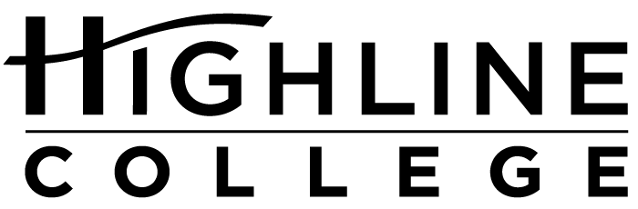

MEDIA RELEASE

FOR RELEASE: Immediately
DATE: February 11, 2016
CONTACT: Dr. Rolita Flores Ezeonu: (206) 592-3373, rezeonu@highline.edu
Kari Coglon Cantey: (206) 291-8622, kcantey@highline.edu
Dr. Lisa Skari: (206) 870-3705, lskari@highline.edu
Sisavatdy to lead new Highline College program
$1.5 million grant funds program for Asian American and Pacific Islander students

DES MOINES, Wash. — Ekkarath “Ekk” Sisavatdy has been selected as the Director of the AANAPISI program at Highline College. It is a new position at the college, resulting from a five-year, $1.5 million grant from the U.S. Department of Education to increase enrollment of and provide extra support for Asian American and Pacific Islander students.

Highline is an Asian American and Native American Pacific Islander-Serving Institution—or AANAPISI—because it has an undergraduate enrollment of at least 10 percent Asian American and Pacific Islander (AAPI) students. The enrollment threshold is determined by the U.S. Department of Education. Highline serves the most diverse community in the state, which is mirrored in its student population that includes approximately 70 percent students of color, more than 20 percent of whom are AAPI.

Prior to his appointment, Sisavatdy served as a program manager in Highline’s Advising department. During his eight years at the college, he has played key roles in managing Running Start enrollment, developing an orientation for new students, and creating innovative practices for students on academic probation, which helps them stay in school and be successful.

“Ekk brings to the position a variety of professional and personal strengths,” said Dr. Rolita Flores Ezeonu, Dean of Instruction for Transfer and Pre-College Education. “We are fortunate to have the opportunity to draw on Ekk’s experiences, his academic background, and his passion for helping the AAPI community.”

In 2011, Sisavatdy was one of the co-founders of the Southeast Asian Education Coalition, based in south King County. He also served as a Leadership in Action intern with Leadership Education for Asian Pacifics, where he worked in the Asian and Pacific Islander community in Southern California, and was selected to attend a weeklong Leadership and Advocacy Training program conducted by the Southeast Asia Resource Action Center in the District of Columbia. He currently serves as an Arts Commissioner with the City of Des Moines.

Sisavatdy lives in Des Moines and has worked in higher education in Washington for approximately 12 years.

He earned his bachelor’s degree in interdisciplinary studies, focusing on the sociopolitical effects of Southeast Asians in the United States, at Western Washington University and his master’s degree in higher education at Central Washington University.

Highline College is one of only ten higher education institutions nationwide to receive AANAPISI grant and the only one in the state of Washington.

# # #

Highline College was founded in 1961 as the first community college in King County. With nearly 17,000 annual students and 350,000 alumni, it is one of the state’s largest institutions of higher education. The college offers a wide range of academic transfer, professional-technical education and bachelor’s degree programs. Alumni include former Seattle Mayor Norm Rice, entrepreneur Junki Yoshida and former Washington state poet laureate Sam Green.

Attachment: Photo of Ekkarath “Ekk” Sisavatdy

