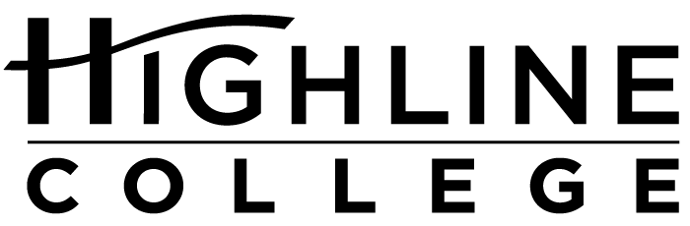

MEDIA RELEASE

FOR RELEASE: Immediately
DATE: March 1, 2016
CONTACT: Tracy Brigham: (206) 592-3449, tbrigham@highline.edu
Kari Coglon Cantey: (206) 291-8622, kcantey@highline.edu
Dr. Lisa Skari: (206) 870-3705, lskari@highline.edu
Free Health Fair Coming to Highline
Event will feature more than 40 information booths

DES MOINES, Wash. — The public is invited to Highline College’s annual Health Information Fair on Wednesday, March 9, 2016, 9:30 a.m.–1 p.m. The free event will be held in Building 8 on the college’s main campus.

Attendees can learn about a wide range of health-related topics, including chronic diseases, eating disorders, fitness, infectious diseases, nutrition, public health issues and more. Topics will be presented by Highline students and faculty from Allied Health, Personal Fitness Training and other programs as well as representatives from college departments, such as Counseling Services and Women’s Programs.

Highline staff will be on site to administer health assessments such as fitness levels, functional movement screening and blood pressure tests.

New this year will be two health assessments that cost $49 each or $88 for both:
— “Get Tanked,” a mobile underwater tank that measures body fat during a 10-minute session. Participants should bring a swimsuit and towel.
— Bone mineral density test, which is a quick, noninvasive process that will expose the risk of fracture from thinning bones.

Appointments for the two assessments are available between 7 a.m. and 1 p.m. Contact Tim Vagen: (206) 592-4610 or tvagen@highline.edu.

For more information about the fair, contact Tracy Brigham at (206) 592-3449 or tbrigham@highline.edu.

Highline’s main campus is located in Des Moines, midway between Seattle and Tacoma at South 240th Street and Pacific Highway South (Highway 99).

# # #

Highline College was founded in 1961 as the first community college in King County. With nearly 17,000 annual students and 350,000 alumni, it is one of the state’s largest institutions of higher education. The college offers a wide range of academic transfer, professional-technical education and bachelor’s degree programs. Alumni include former Seattle Mayor Norm Rice, entrepreneur Junki Yoshida and former Washington state poet laureate Sam Green.

