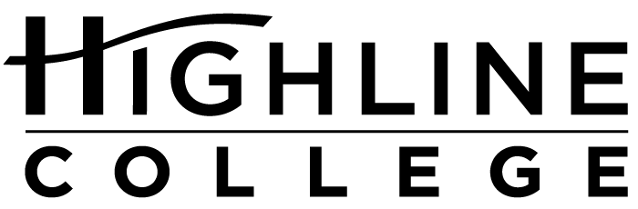

CALENDAR ITEM

FOR RELEASE: Immediately
DATE: April 1, 2016
CONTACT: Dr. Meg Ryan: (253) 222-4575, mryan@highline.edu
Kaitlin Bermingham: (206) 592-3419, kbermingham@highline.edu
Kari Coglon Cantey: (206) 291-8622, kcantey@highline.edu
Dr. Lisa Skari: (206) 870-3705, lskari@highline.edu

Forum to Highlight Threats to Global Supply Chains
Free event at Highline College will explore solutions to cybercrimes and physical crimes

Event: Securing the Supply Chain Forum

Date: Wednesday, April 13, 2016

Time: 9 a.m.–5 p.m.

Price: Free, but space is limited; register at coeglobaltrade.com/events

Location: Highline College’s main campus; Building 2

Highline College’s main campus is located midway between Seattle and Tacoma at South 240th Street and Pacific Highway South (Highway 99); address: 2400 S. 240th St., Des Moines, Wash.

Description: Cybercrimes and physical crimes present a real threat to global supply chains. As criminals find vulnerabilities, migrating risk and optimizing global cargo flow become a great challenge. The Centers are pleased to announce two keynote speakers: Eric Kready, Director of Operations, Intelligence Manager, Program Manager, FreightWatch International; and Dr. Amelia Phillips, Computer Information Systems faculty at Highline College. The purpose of this forum is to assess current threats in our supply chains and identify solutions for prevention and resolution of risk. In addition, curriculum gaps and training will be explored to inform updates to supply chain management curriculum in our public colleges and universities.

Sponsors: The Centers of Excellence for Global Trade & Supply Chain Management and Homeland Security & Emergency Management

For more information: Kaitlin Bermingham: (206) 592-3419 or kbermingham@highline.edu

# # #

Highline College was founded in 1961 as the first community college in King County. With nearly 17,000 annual students and 350,000 alumni, it is one of the state’s largest institutions of higher education. The college offers a wide range of academic transfer, professional-technical education and bachelor’s degree programs. Alumni include former Seattle Mayor Norm Rice, entrepreneur Junki Yoshida and former Washington state poet laureate Sam Green.

