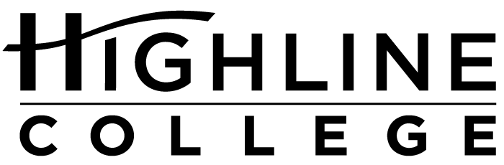

MEDIA RELEASE

FOR RELEASE: Immediately
DATE: April 19, 2016
CONTACT: Doris Martinez: (206) 592-4319, dmartinez@highline.edu
Kari Coglon Cantey: (206) 291-8622, kcantey@highline.edu
Dr. Lisa Skari: (206) 870-3705, lskari@highline.edu

Free Weeklong Program Celebrates and Explores Diversity
Unity Through Diversity Week in 19th year at Highline College

DES MOINES, Wash. — The public is invited to celebrate and explore diversity and contemporary social justice issues during Unity Through Diversity Week at Highline College, April 25–29, 2016. Now in its 19th year, the weeklong program looks at the diversity of the south King County community in all forms: race, gender, class, sexual orientation, ability and religion.

United by the theme “Rewiring Our Minds: Reconnecting Our Roots Across Invisible Borders,” Unity Through Diversity Week will include free lectures and workshops by guest speakers and campus experts.

“This year’s program focuses on dismantling what is blocking humanity from connecting authentically,” said Doris Martinez, who is one of the organizers of the event. “With the various challenges our global community faces, our planning committee is deeply committed to providing our community the space to partake in conversations regarding various topics highlighted throughout the week, but also to celebrate the strengths of our diverse intersections.”

Unity Through Diversity Week is sponsored by Multicultural Affairs and the Center for Leadership and Service. All events are free and open to the public.

Highline’s main campus is located midway between Seattle and Tacoma at South 240th Street and Pacific Highway South (Highway 99); address: 2400 S. 240th St., Des Moines, Wash.

For more information, contact Doris Martinez, Highline’s Director of Student Diversity and Inclusion: dmartinez@highline.edu or (206) 592-4319.

Event Schedule:

Monday, April 25, 2016
9–10:30 a.m.
Lecture by Olin Tezcatlipoca, Director of Mexica Movement: “Learning and Teaching the Truth of the Last 500 Years of Colonialism”
Building 7

1:30–3 p.m.
Workshop by Olin Tezcatlipoca, Director of Mexica Movement: “Learning and Teaching Truth As a Solution to the Colonized Minds That We Have Inherited”
Building 8, Mt. Constance room

Tuesday, April 26, 2016
10–11:30 a.m.
Lecture by Imam Benjamin Shabaaz: “Intersections of Oppression: An African American Muslim Perspective”
Building 7

11 a.m.–12 p.m.
Poetry reading by Rick Barot
Building 8, Mt. Constance room

12:30–3 p.m.
Workshop by LGBTQIA Taskforce: “LGBTQIA Safe Zones Inclusivity Training Program, Part 1”
Building 2

Wednesday, April 27, 2016
11 a.m.–12:50 p.m.
Workshop by Barbara Talkington, Highline Multicultural Leadership Advisor, and Richelle Enriquez, Associated Students of Highline College Vice President: “Bystander Intervention”
Building 2

Thursday, April 28, 2016
11 a.m.–12:30 p.m.
Lecture and film presented by Tracy Rector of Longhouse Media: “Indigenous Thoughts on Borders: Clearwater”
Building 7

1:30–3 p.m.
Workshop by Jeffon Seely: “The Leap: From Ordinary to Extraordinary”
Building 8, Mt. Constance room

Friday, April 29, 2016
10–11:30 a.m.
Lecture by authors Robin Yassin-Kassab and Leila Al-Shami: “Syrians Also Have Dreams: Refugees, Islamophobia, and Media Misrepresentations of the Syrian War”
Building 7

2–4 p.m.
Workshop by Dr. Leticia Nieto and Yvette D. Murrell: “Exploring Social Interactions Beyond Invisible Borders”
Building 8, Mt. Constance room

# # #

Attachment: Photo of Doris Martinez

Highline College was founded in 1961 as the first community college in King County. With nearly 17,000 annual students and 350,000 alumni, it is one of the state’s largest institutions of higher education. The college offers a wide range of academic transfer, professional-technical education and bachelor’s degree programs. Alumni include former Seattle Mayor Norm Rice, entrepreneur Junki Yoshida and former Washington state poet laureate Sam Green.

