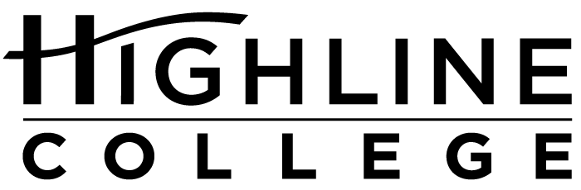

MEDIA RELEASE

FOR RELEASE: Immediately

DATE: May 2, 2017

CONTACT: Rashad C. Norris: (206) 592-3939, rnorris@highline.edu
Kari Coglon Cantey: (206) 291-8622, kcantey@highline.edu

450+ Expected at Event for Young Women of Color

Y.E.L.L. Summit at Highline College Designed for South King County Students

DES MOINES, Wash. — Young women of color are invited to Highline College for the Y.E.L.L. Summit, a free event designed to empower, encourage and educate. Y.E.L.L., short for Young Educated Ladies Leading, is scheduled for May 20, 2017, and designed for south King County students in 9th grade and above.

Last year the Y.E.L.L. Summit drew approximately 450 participants, and event organizers are expecting a similar turnout this year. It is free and open to the public, but registration by May 12 is required. Registration information is available at yell.highline.edu. Participants will receive giveaways, prizes, breakfast and lunch.

During the summit, which will run from 8 a.m. to 3:30 p.m., students will attend one of 11 workshops, participate in a leadership activity and hear from a panel of professional women of color.

Rocky Rivera, who identifies herself not as a female MC, but as an artist who makes movement music for the masses, will give the keynote address. In addition to pursuing various music projects, Rivera works as a youth development coordinator in Oakland and writes for publications such as Rolling Stone, The Source and Vibe.

Rivera’s creative delivery through music and her unique skill set, life experience and Filipino roots will draw in students, according to Rashad Norris, who is one of the summit’s organizers and Highline’s Director of Community Engagement. Rivera consistently incorporates equity, social justice and intersectionality in her music, writing and youth work.

“Having Rivera deliver her inspirational and artistic messages will be a treat for our young women,” said Norris. “She will focus on the need to communicate the stories and struggles of our communities in a constructive way.”

The Y.E.L.L. Summit is patterned after Highline’s Black and Brown Male Summit, a popular event each fall for young men of color in South King County.

Like the Black and Brown, the Y.E.L.L. Summit is underwritten by the college with special support by Highline’s Access Services and the Office of the President.

The summit will be held in Highline’s Student Union (Building 8) on the college’s main campus, located midway between Seattle and Tacoma at South 240th Street and Pacific Highway South (Highway 99).

# # #

Attachment: Photo of Rashad Norris

Celebrating its 55th anniversary, Highline College was founded in 1961 as the first community college in King County. With nearly 17,000 annual students and 350,000 alumni, it is one of the state’s largest institutions of higher education. The college offers a wide range of academic transfer, professional-technical education and applied bachelor’s degree programs. Alumni include former Seattle Mayor Norm Rice, entrepreneur Junki Yoshida and former Washington state poet laureate Sam Green.

