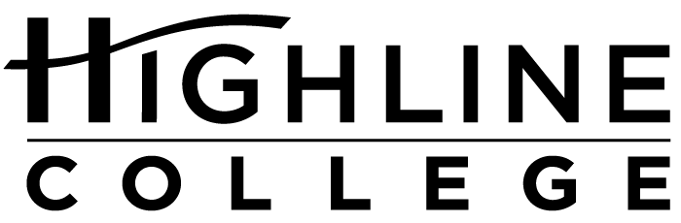

MEDIA RELEASE

FOR RELEASE: Immediately

DATE: October 17, 2016

CONTACT: Katy Kachmarik: (206) 592-4488, kkachmarik@highline.edu
Kayla Grattan: (206) 592-4590, kgrattan@highline.edu
Kari Coglon Cantey: (206) 291-8622, kcantey@highline.edu

Underwater Pumpkin Carving and More

Highline College’s MaST Center offers free events for fall fun

DES MOINES, Wash. — Community members are invited to a wide range of events sponsored by Highline College’s Marine Science and Technology (MaST) Center during fall quarter 2016. All events are free and open to the public and will be held at the MaST Center, unless otherwise noted.

The MaST Center is located on the Redondo Dock next to Salty’s at 28203 Redondo Beach Drive S., Des Moines, Wash. The event schedule is subject to change. For updates and more information, visit mast.highline.edu.

October 22, 10 a.m.–12 p.m.
October 26*, 5:30–7 p.m.
Marine Mammal Stranding Team Training
Attend an orientation session to learn about the MaST Center’s Marine Mammal Stranding Team. This unique team provides hands-on experience with marine mammals, public education and public outreach while helping the amazing creatures in Puget Sound. The content of each session will be identical. Open to participants 16 years of age and older. *October 26 training will be held at Foss Waterway Seaport, 705 Dock St., Tacoma, Wash.

October 29, 10 a.m.–2 p.m.
Fear on the Pier
Visit the center for a Halloween-themed Discovery Day event featuring creepy and cool critters of Puget Sound, skeletons, slime and more. Underwater pumpkin carving, hosted by Underwater Sports, will begin at 1 p.m. Visitors will be able to watch the carving live on big screen TVs. Marine-themed costumes encouraged.

November 5, 4–7:30 p.m.
Squid-A-Rama
This annual event is put on in conjunction with the Des Moines Arts Commission and features art and science activities for all ages. Enjoy hot chocolate and coffee as well as Salty’s chowder available for purchase. Learn more: desmoinesartscommission.com.

December 15, 7:30–9:30 p.m.
Argosy Christmas Ships
Get a front row seat to the annual Argosy Christmas Ships Festival. Visitors are welcome to enjoy the aquarium while they wait or warm up with a bonfire on the beach. Performance at Redondo: 9–9:20 p.m.

More Free Fun: The MaST Center also offers monthly presentation as part of its Science on the Sound series as well as weekly Discovery Days, when its aquarium is open for public viewing each Saturday, 10 a.m.–2 p.m. Learn more: mast.highline.edu.

# # #

About the MaST Center:
Highline’s MaST Center promotes understanding, appreciation and preservation of the marine environment through hands-on research, education and community activities that highlight the beauty, complexity and importance of the south Puget Sound ecosystem. It offers an aquarium, research space and a unique waterfront laboratory and classroom and provides a venue to educate and engage the community in issues impacting Puget Sound, including coastal development, storm water runoff, marine pollution and salmon recovery.

About Highline College:
Celebrating its 55th anniversary, Highline College was founded in 1961 as the first community college in King County. With nearly 17,000 annual students and 350,000 alumni, it is one of the state’s largest institutions of higher education. The college offers a wide range of academic transfer, professional-technical education and applied bachelor’s degree programs. Alumni include former Seattle Mayor Norm Rice, entrepreneur Junki Yoshida and former Washington state poet laureate Sam Green.

