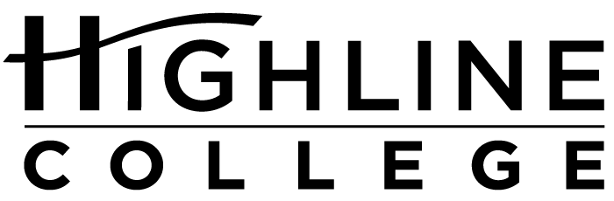

MEDIA RELEASE

FOR RELEASE: Immediately
DATE: October 18, 2016
CONTACT: Chantal Carrancho: (206) 592-4026, ccarrancho@highline.edu
Kari Coglon Cantey: (206) 291-8622, kcantey@highline.edu

Free Job Fair at Highline College
Nearly 50 employers expected at October 26 event

DES MOINES, Wash. — Close to 50 local employers with full-time, part-time and temporary job opening will be represented at Highline College’s Fall Job Fair. The event is free and open to the public; no advance registration is necessary.

Date: Wednesday, October 26, 2016
Time: 11 a.m.–2 p.m.
Location: Highline College’s main campus, Building 8
Information: For details, visit studentemployment.highline.edu.

Highline College’s main campus is located midway between Seattle and Tacoma at South 240th Street and Pacific Highway South (Highway 99); address: 2400 S. 240th St., Des Moines, Wash.

Employers from a wide variety of industries will be represented. Attendees should be prepared to speak with recruiters, dress professionally and bring extra copies of their resume.

Free career workshops are also available to prepare for the fair. Learn more at studentemployment.highline.edu/workshops.

Participating Employers:
Advanced Health Care
Aegis Living
Apartment Advantage Staffing
Aquatic Management Group
Associated Recreation Council
Bahama Breeze
Camp Fire Central Puget Sound
City of Des Moines Parks and Recreation
Comcast
Confluence Health
Creative Living Services
Digestive Health Specialists
Express Employment Professionals (Kent)
Federal Way Public Schools
FedEx Ground
Highline College Human Resources
Highline Public Schools
Iden’s Dealer Services
Keiro Northwest
Korean Women’s Association
Life Care Centers of America
Macy’s
Northwest Hospital & Medical Center
O’Brien Auto Group
Phoenix Protective Corporation
Port Jobs – Airport Jobs
Primerica Manivanh & Associates
Puget Sound Educational Services District (PSESD)
Renton School District
ResCare Homecare
Robbins and Company
Seattle Goodwill
Silver Cloud Inns & Hotels
Sound Transit
State of Washington, Department of Corrections – Monroe Correctional Complex
Tacoma Community College
The Hertz Corporation
University of Washington Medical Centers
US Bank In-Store Greater Seattle
U.S. Marine Corps
Uwajimaya
Village Green Retirement Campus
Washington State Convention Center
Washington State Patrol
Wesley Homes
Wyndham Vacation Ownership
Young Minds Development Academy

# # #

Celebrating its 55th anniversary, Highline College was founded in 1961 as the first community college in King County. With nearly 17,000 annual students and 350,000 alumni, it is one of the state’s largest institutions of higher education. The college offers a wide range of academic transfer, professional-technical education and bachelor’s degree programs. Alumni include former Seattle Mayor Norm Rice, entrepreneur Junki Yoshida and former Washington state poet laureate Sam Green.

