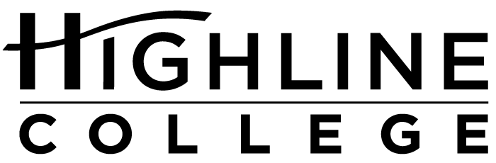

MEDIA RELEASE

FOR RELEASE: Immediately

DATE: November 28, 2016

CONTACT: Toni Castro: (206) 592-3351, tcastro@highline.edu
Kari Coglon Cantey: (206) 291-8622, kcantey@highline.edu

Saechao Promoted to Administrative Role at Highline College
Diverse student population benefits from his experience as first-generation college student from refugee family

DES MOINES, Wash. — Ay Saechao has been promoted to Associate Dean for Student Development, Retention and Conduct at Highline College.

Since 2011, Saechao has made significant contributions to the success of Highline’s TRiO Student Support and Retention Services program, New Student Experience Seminar and the college. One of the main goals of the TRiO program is to help students from groups traditionally underrepresented in postsecondary education improve their chances of graduating from college. Under Saechao’s leadership, the program has exceeded national benchmarks in student persistence, graduation and university transfer.

Recently, he directed the grant team in earning a renewal of Highline’s $1.1 million federal grant for TRiO through 2020. Saechao will continue to serve as Director of Highline’s TRiO program.

“Having been the TRiO Director for the past three years, I hope to expand the success of our TRiO program and our approach with the broader campus community,” Saechao said. “In addition, as the new Student Conduct Officer, I plan to continue the great work from my predecessor and collaborate with campus staff, faculty, students and administrators to ensure we foster a supportive and safe learning environment.”

Additionally, Saechao is the founding co-chair of the Southeast Asian Education Coalition (SEAeD), located in south Puget Sound, a nonprofit community organization that addresses legislative policy, opportunity gaps and other educational concerns of the Southeast Asian American community. In the summer of 2015, Saechao was invited to the White House to showcase the work of the SEAeD Coalition. As a Mienh American, Saechao is proud to lead this important work for the community. He lives in Auburn.

“Ay’s unwavering dedication to access, equity, engagement and academic achievement provides an excellent foundation for success in his new administrative position,” said Toni Castro, Highline’s Vice President for Student Services.

Saechao earned a master’s degree in multicultural education (curriculum and instruction) from the University of Washington and a bachelor’s degree in cultural anthropology from Oregon State University.

“Having been a first-generation college student, and being raised in a refugee family and community, this means a lot to me. My experience witnessing friends and family struggle to succeed in school has driven me to strive for educational equity for all students, especially those underrepresented,” said Saechao, whose parents are from Laos. “Being promoted to Associate Dean is a great honor that provides me additional opportunities to empower our community.”

People representing more than 120 cultures attend classes at the college. With over 70 percent students of color, Highline ranks as the most diverse higher education institution in the state.

# # #

Attachment: Photo of Ay Saechao

Celebrating its 55th anniversary, Highline College was founded in 1961 as the first community college in King County. With nearly 17,000 annual students and 350,000 alumni, it is one of the state’s largest institutions of higher education. The college offers a wide range of academic transfer, professional-technical education and applied bachelor’s degree programs. Alumni include former Seattle Mayor Norm Rice, entrepreneur Junki Yoshida and former Washington state poet laureate Sam Green.

