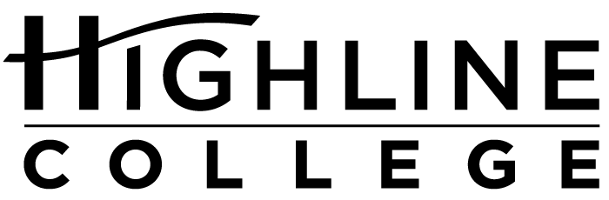

MEDIA RELEASE

FOR RELEASE: Immediately

DATE: January 4, 2018

CONTACT: Doris Martinez: (206) 592-4319, dmartinez@highline.edu
Kari Coglon Cantey: (206) 291-8622, kcantey@highline.edu

50 Years After Martin Luther King Jr.

Week of Free Events Begins Jan. 16 at Highline College

DES MOINES, Wash. — The public is invited to free events January 16–19, 2018, as Highline College hosts its 23rd annual Martin Luther King Jr. Week celebration.

United by the theme “50 Years Later: Dreams vs. Reality,” speakers and performers will explore America today, 50 years after the assassination of the civil rights leader.

Event Schedule
All events will be held on the college’s main campus in Des Moines, located midway between Seattle and Tacoma at South 240th Street and Pacific Highway South (Highway 99). Find full event descriptions on the Office of Multicultural Affairs webpage.

Tuesday, Jan. 16, 2018

10–11:30 a.m.
Keynote address by Aaron Reader, dean of students at Renton Technical College: “MLK 50 Years Later: Unedited”
Building 7

1:30–3 p.m.
Lecture by Cecile Hansen, chair of the Duwamish Tribe: “The Sacred Fight for Justice of the Duwamish Tribe”
Building 7

Wednesday, Jan. 17, 2018

11 a.m.–12:30 p.m.
Lecture by PK Thompson, theologian: “‘The Woke King’: Re-Imaging Martin Luther King, Jr.’s ‘Beloved Community’ in a Donald Trump America”
Building 8, Mt. Constance Room

1:30–3 p.m.
Lecture by Dr. Benjamin Gonzalez, faculty at Highline College: “Immigration and the American State: Considering Our Past, Present and Future”
Building 8, Mt. Constance Room

6–7:30 p.m.
Performance by Living Voices, a storytelling group that brings life to history: “The Right to Dream”
Building 7

Thursday, Jan. 18, 2018

1:30–3 p.m.
Lecture by Dr. Shon Meckfessel, faculty at Highline College: “When ‘Free Speech’ Is Actually Its Opposite: The First Amendment, Hate Speech and the Privilege of Platforms”
Building 8, Mt. Constance Room

Friday, Jan. 19, 2018

10–11:30 a.m.
Lecture by Robert Britten, faculty at Pierce College: “King and the Role of Capitalism, Militarism and Racism in Achieving Peace”
Building 7

2–4 p.m.
Workshop facilitated by Mozart Guerrier, executive director of 21 Progress: “We Lead: We Are the Ones We’ve Been Waiting For”
Building 8, Mt. Constance Room

# # #

Links within this release:
- Highline College’s main campus: https://www.highline.edu/campus-guide/locations-and-directions/
- Office of Multicultural Affairs: https://multiculturalaffairs.highline.edu/mlkweek.php

Founded in 1961 as the first community college in King County, Highline College annually serves more than 17,000 students. With over 70 percent students of color, Highline is the most diverse higher education institution in the state. The college offers a wide range of academic transfer, professional-technical education, basic skills and applied bachelor’s degree programs. Alumni include former Seattle Mayor Norm Rice, entrepreneur Junki Yoshida and former Washington state poet laureate Sam Green.

