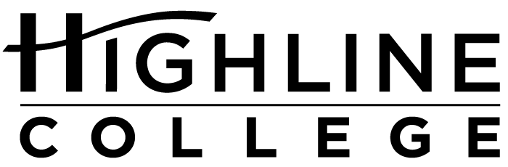

MEDIA RELEASE

FOR RELEASE: Immediately

DATE: January 6, 2017

CONTACT: Susan Rich: (206) 592-3253, srich@highline.edu
Sean Puno: (206) 592-4082, spuno@highline.edu
Kari Coglon Cantey: (206) 291-8622, kcantey@highline.edu

Film Festival to Show Work of 5 Students
Film contest winners earn recognition, cash prizes at Highline College

DES MOINES, Wash. — A tender film focused on family and backed by a simple soundtrack took top honors in Highline College’s film contest, a prelude to the 2017 Highline Film Festival. The contest was open to current students and alumni.

With a running time of 3 minutes, 36 seconds, “The Home Within” earned Kelsey Par first place and a $250 cash prize. Par’s film, along with three films by the four other finalists, will be screened during the Highline Film Festival, scheduled for January 25, 2017, at 1 p.m. in Building 7 on the college’s main campus. The event is free and open to the public.

“This is actually the first film I have ever made. I have always been passionate about photography and film, but never really had the resources until just recently,” said Par, who shot her film using a Canon EOS 60D, her father’s old camera. “This film has led me to believe I might have a talent for making films and plan to make many more films in the future. My ideas are endless and as long as I have the resources I know I can fulfill my passion.”

Contestants were challenged to create a short film not to exceed eight minutes, focused on the theme of “home,” containing a scene with a location, art piece or landmark on the Highline College campus.

“I have moved around many times in my life. Despite the troubles that came from constantly having to pack up and move, it didn’t matter because I had my family by my side,” said Par, who recently moved to Des Moines from Federal Way. “I realized that it doesn’t matter where you live as long as the people you love are with you. That is why I felt so passionate about creating this short film. I wanted to spread the message to those around me.”

Par used several family members in her film: her mom, Anna; sister, Taylor, 7 years old; brother, James, 5; and nephew, Brayden, 1. All are planning on attending the January 25 film screening.

Par will earn her associate degree this summer from Highline, where she is an editor for the student newspaper, The Thunderword, and a consultant in the college’s Writing Center. She plans on transferring to the University of Washington to study journalism and film.

Second place, with a prize of $125, went to Nina Releford of Federal Way for “Holiday Video.” She is studying multimedia at Highline.

Third place and $100 went to a duo from Kent for the animated film “Home Is Where the Heart Is.” It was written by Lisa Lopez and animated by Samantha Montes de Oca. Both finished their studies at Highline in 2016.

Fourth place and $75 went to Matthew MacDonald of Des Moines for “Double Identity.” He is in his second year at Highline.

“Highline’s Film Studies program and Multimedia Design classes are attracting more and more students interested in film and video; the festival encourages student creativity and brings the work out into the world,” said Susan Rich, a Highline faculty member who was one of the contest judges.

Rich noted that this is the college’s first film festival in a decade or so. The previous one was held by a student club, while this one is sponsored by Highline’s Humanities department. Joining Rich as judges were Dr. Tommy Kim, who teaches literature and film studies, and Sean Puno, who teaches multimedia design.

Films were judged on creativity, story structure and production value. The contest was free to enter. Contestants could work individually or as part of a team and could enter up to three films.

More information about the contest, including guidelines and resources, is available on the Highline Film Festival blog: https://HighlineFilmFestival.blogs.highline.edu.

Par’s film can be viewed at https://www.youtube.com/watch?v=XlbcSI8jjug.

Highline’s main campus is located midway between Seattle and Tacoma at South 240th Street and Pacific Highway South (Highway 99).

# # #

Attachment: Photo of Kelsey Par

Celebrating its 55th anniversary, Highline College was founded in 1961 as the first community college in King County. With nearly 17,000 annual students and 350,000 alumni, it is one of the state’s largest institutions of higher education. The college offers a wide range of academic transfer, professional-technical education and applied bachelor’s degree programs. Alumni include former Seattle Mayor Norm Rice, entrepreneur Junki Yoshida and former Washington state poet laureate Sam Green.

