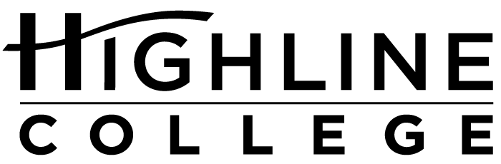

MEDIA RELEASE

FOR RELEASE: Immediately
DATE: January 26, 2016
CONTACT: Kari Coglon Cantey: (206) 291-8622, kcantey@highline.edu
Dr. Lisa Skari: (206) 870-3705, lskari@highline.edu
Highline College among nation’s leading community colleges
Top 150 recognition makes college eligible for 2017 Aspen Prize

DES MOINES, Wash. — Today Highline College was named one of the nation’s top 150 community colleges by the Aspen Institute College Excellence Program. The honor gives Highline the chance to compete for the 2017 Aspen Prize for Community College Excellence and $1 million in prize funds.

“Being recognized as one of the top 150 community colleges in the nation reflects Highline’s innovative efforts to support student access and attainment,” said Dr. Jack Bermingham, president of Highline College. “My colleagues take great pride in their success in making a difference in the lives of our students, working together every day to create equitable and inclusive opportunities.”

The Aspen Prize is the nation’s signature recognition of high achievement and performance among America’s community colleges. It recognizes institutions for exceptional student outcomes in four areas: student learning, certificate and degree completion, employment and earnings, and access and success for minority and low-income students.

Started in 2011, the Aspen Prize is awarded every two years. Washington two-year colleges have fared well in past competitions. In 2015, Renton Technical College was one of 10 finalists. In 2013, Walla Walla Community College was a co-winner with California’s Santa Barbara City College.

Highline, along with the other 149 community colleges, was selected from a national pool of more than 1,000 public two-year colleges using publicly available data on student outcomes in three areas:
— Performance: retention, graduation rates including transfers, and degrees and certificates per 100 full-time equivalent students.
— Improvement: awarded for steady improvement in each performance metric over time.
— Equity: evidence of strong completion outcomes for minority and low-income students.

Nearly half of America’s college students attend community college, with more than seven million students—youth and adult learners—working towards certificates and degrees in these institutions across the country.
“Community colleges have tremendous power to change lives, and their success will increasingly define our nation’s economic strength and the potential for social mobility in our country,” said Josh Wyner, executive director of the Aspen Institute College Excellence Program. “This competition is designed to spotlight the excellent work being done in the most effective community colleges, those that best help students obtain meaningful, high-quality education and training for competitive-wage jobs after college. We hope it will raise the bar and provide a roadmap to better student outcomes for community colleges nationwide.”

Ten finalists will be named in fall 2016. The Aspen Institute will then conduct site visits to each of the finalists and collect additional quantitative data. A distinguished Prize Jury will select a grand prize winner and a few finalists with distinction in early 2017.

Recognition by the Aspen Institute adds to Highline’s recent awards and honors:
— Higher Education Excellence in Diversity Award three years in a row, 2013–2015, from Insight into Diversity magazine (one of the few two-year colleges recognized nationally).
— 2014 Award of Excellence for Advancing Diversity from the American Association of Community Colleges.
— Community College Week top 100 associate degree producers in 2014 (48th in associate degree producers for Asian-American students) and in 2013 (53rd in associate degree producers for Asian-American students, 29th in certificate producers for African-American students).
— Great College to Work For recognition in 2015, 2013, and 2010 by The Chronicle of Higher Education.

Eight other Washington colleges are among the top 150, recognizing the state’s strong two-year system:
— Clark College
— Everett Community College
— Olympic College
— Pierce College
— Renton Technical College
— South Puget Sound Community College
— Tacoma Community College
— Whatcom Community College

A full list of the selected colleges and details on the selection process are available at aspenprize.org.

# # #

About Highline College
Highline College was founded in 1961 as the first community college in King County. With nearly 17,000 annual students and 350,000 alumni, it is one of the state’s largest institutions of higher education. The college offers a wide range of academic transfer, professional-technical education and bachelor’s degree programs. Alumni include former Seattle Mayor Norm Rice, entrepreneur Junki Yoshida and former Washington state poet laureate Sam Green.

About the Aspen Prize and the Aspen College Excellence Program
The Aspen Prize is funded by the Joyce Foundation, the Siemens Foundation and the Kresge Foundation.

The Aspen College Excellence Program aims to advance higher education practices, policies and leadership that significantly improve student outcomes. Through the Aspen Prize for Community College Excellence, the New College Leadership Project and other initiatives, the College Excellence Program works to improve colleges’ understanding and capacity to teach and graduate students, especially the growing population of low-income and minority students on American campuses. For more information, visit aspeninstitute.org/college-excellence.

The Aspen Institute is an educational and policy studies organization based in Washington, DC. Its mission is to foster leadership based on enduring values and to provide a nonpartisan venue for dealing with critical issues. The Institute is based in Washington, DC; Aspen, Colorado; and on the Wye River on Maryland’s Eastern Shore. It also has offices in New York City and an international network of partners. For more information, visit aspeninstitute.org.

