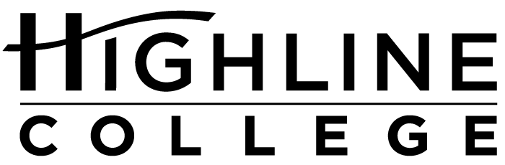

MEDIA RELEASE

FOR RELEASE: Immediately
DATE: February 2, 2016
CONTACT: Cesar Rangel: (206) 592-4672, crangel@highline.edu
Kari Coglon Cantey: (206) 291-8622, kcantey@highline.edu
Dr. Lisa Skari: (206) 870-3705, lskari@highline.edu
Local artist and educator lends time and talent to Latino Summit
Highline College will host second annual event for Latino students

DES MOINES, Wash. — As a Latina educator, participating in Highine College’s upcoming Latino Summit on February 23−24 is especially meaningful for artist Tracy Carrera.

In addition to co-leading a workshop session, Carrera gave permission for one of her paintings to be used in materials promoting the two-day event.

“When I was asked to be a part of this year’s Latino Summit, I was so proud and so excited, and I thought this image matched the richness and boldness and strength of what the Latino Summit is all about,” said Carrera, who joined Highline’s faculty in 2013 as a fine art instructor.

During her talk, she will reference that painting, a 2003 piece titled “Chingon Hermana Who Wears the Serpent Dress (Coatlicue).”

The image depicts Carrera’s version of the Aztec primordial earth goddess. The inspiration was Carrera’s identical twin sister Randi, who had conquered her seven-year-long methamphetamine addiction.

“In the painting, my sister is wearing a red bandanna, which speaks to the working class background we come from,” said Carrera.

Her expression—calm, looking forward at the viewer—shows a woman who is unashamed and triumphant.

The oil painting’s rich earthy colors—such as yellow ocher, cadmium red and oxide brown—reflect Carrera’s Southwestern influences. Born and raised in Utah, she earned her BFA and MFA in painting and illustration from Utah State University. She also spent a number of years living in California and New Mexico before coming to Washington. She now lives in Kent.

The serpent adorning the woman’s dress “has special meaning to me as a Chicana. Quetzalcoatl is the plumed serpent, a Mesoamerican deity, known as the god of wind and learning.

“I enjoy referencing Mesoamerican iconography in my work. I’m proud of my culture.”

That pride is something she intends to share with summit attendees when she discusses how U.S. pop culture and her upbringing has influenced her self-identification as a Chicana, which has been a source of strength and pride in her creative career as a sensual impressionist painter.

“I’m so proud to be working with my Latino/a colleagues as part of the Latino Summit Committee. All of us on the committee want to empower Latino/a youth to embrace higher education and knowledge. It is our right and our duty to know ourselves and the world so we can contribute our special gifts to the world.”

The second annual summit will bring together high school and college students from the south King County community to learn and celebrate. The two-day event will include workshops and speakers designed to provide Latino students with the tools they need for success in higher education and beyond.

Guest speakers, including educators and graduates from Highline College, will share both their professional and personal experiences with attendees.

The free summit is open to all and will be held February 23−24, 8:30−11:50 a.m., on Highline’s main campus in the Student Union (Building 8).

The summit is an extension of Highline’s commitment to diversity, social justice and multiculturalism for which the college has earned several awards and recognition.

For the third straight year, Highline received the Higher Education Excellence in Diversity (HEED) Award, a national honor recognizing U.S. colleges and universities that demonstrate an outstanding commitment to diversity and inclusion. Given by Insight into Diversity magazine, the 2015 HEED Award was presented to only 92 institutions across the nation.

In 2014, the college received a prestigious Award of Excellence from the American Association of Community Colleges for increasing diversity and social equity on campus. Highline was one of six colleges in the nation earning recognition and won in the Advancing Diversity category.

Highline serves the most diverse community in the state, which is mirrored in its student population that includes approximately 70 percent students of color, 19 percent of whom are Hispanic/Latino.

For more information about the Latino Summit, visit highline.edu/latino-summit-2016 or contact Cesar Rangel, Advisor and Retention Coordinator for the Latino Center for Higher Education at Highline: crangel@highline.edu or (206) 592-4672.

# # #

Highline College was founded in 1961 as the first community college in King County. With nearly 17,000 annual students and 350,000 alumni, it is one of the state’s largest institutions of higher education. The college offers a wide range of academic transfer, professional-technical education and bachelor’s degree programs. Alumni include former Seattle Mayor Norm Rice, entrepreneur Junki Yoshida and former Washington state poet laureate Sam Green.
Attachments (3):
1: “Chingon Hermana Who Wears the Serpent Dress (Coatlicue)” by Tracy Carrera, 2003, oil on canvas. Image courtesy of the artist.
2: 2016 Latino Summit promotional poster
3: Photo of Tracy Carrera

