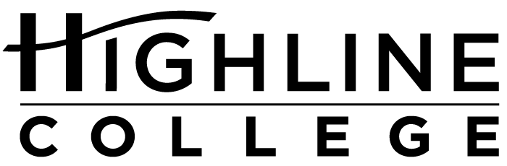

MEDIA RELEASE

FOR RELEASE: Immediately

DATE: February 22, 2017

CONTACT: Dr. Lisa Skari: (206) 870-3705, lskari@highline.edu
Kari Coglon Cantey: (206) 291-8622, kcantey@highline.edu

Study Shows Highline Added $631.5 Million to Local Economy

Research Quantifies Highline’s Economic Impact on Region, Residents

DES MOINES, Wash. — A new study found Highline College alumni and operations added $631.5 million to the King County economy during the 2014–15 fiscal year. The added income translated into 8,675 jobs, according to the economic impact study commissioned by the college.

Conducted by Economic Modeling Specialists International, the study demonstrates that Highline supports King County’s economy through college operations, additional revenues from skilled alumni, and spending by students who came from outside of the county, such as international students.

“We’ve always known that education is an investment. Now we have the numbers to back it up,” said Dr. Lisa Skari, Vice President for Institutional Advancement. “Day after day, we hear personal stories of how education has changed peoples’ lives. It’s gratifying to be able to quantify the impact of education, both to our students and in our region.”

The study looked at spending by students who came into the county to study, alumni who stayed in the area after graduating, and the college itself. It then factored in the multiplier effect that occurs as money is spent and re-spent in the county, turning every dollar spent into more than a dollar in economic activity.

Most of the added income — $550.7 million — came from higher wages and increased productivity from college alumni working in the region. This supported 7,347 jobs. College operations added another $55.4 million or 977 jobs. Spending by international and retained students — or around 9 percent of Highline students — accounted for $25.4 million or 351 jobs. Retained students include those who would have left the county to pursue education elsewhere if Highline did not exist.

The study also calculated the return on investment for students, taxpayers and society.

For every dollar spent, the study found society gained $9.80 in added taxes and public sector savings and taxpayers gained $4.70 in added state revenue and social savings. Social savings come from reduced crime, lower unemployment and better health and wellness.

For every dollar students invest in Highline in the form of out-of-pocket expenses and forgone time and money, they receive a cumulative of $2.30 in higher future earnings, for an average annual rate of return of 10.9 percent. By comparison, the 10-year average rate of return in the U.S. stock market is 7.2 percent.

During the 2014–15 academic year, Highline enrolled 737 international students and employed 822 individuals. Total student enrollment was 16,917. Students originating from King County accounted for more than 90 percent of the total student population, or 15,444 students.

Economic Modeling Specialists International is an independent research company that specializes in economic impact studies for leaders in higher education. Learn more at http://www.economicmodeling.com/.

The full study, supporting documents and infographics are available at https://www.highline.edu/economic-impact/.

# # #

Attachment: Photo of Dr. Lisa Skari

Celebrating its 55th anniversary, Highline College was founded in 1961 as the first community college in King County. With nearly 17,000 annual students and 350,000 alumni, it is one of the state’s largest institutions of higher education. The college offers a wide range of academic transfer, professional-technical education and applied bachelor’s degree programs. Alumni include former Seattle Mayor Norm Rice, entrepreneur Junki Yoshida and former Washington state poet laureate Sam Green.

