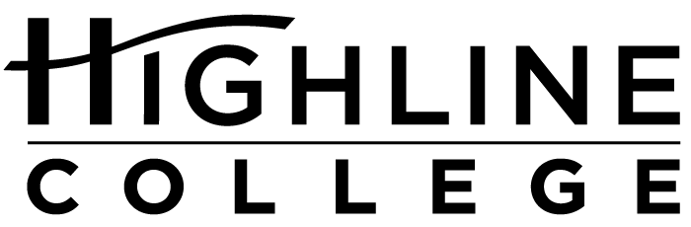

CALENDAR ITEM

FOR RELEASE: Immediately
DATE: April 7, 2016
CONTACT: Dr. Meg Ryan: (253) 222-4575, mryan@highline.edu
Kaitlin Bermingham: (206) 592-3419, kbermingham@highline.edu
Kari Coglon Cantey: (206) 291-8622, kcantey@highline.edu
Dr. Lisa Skari: (206) 870-3705, lskari@highline.edu

Job Fair Focuses on Transportation, Distribution and Logistics
Free event at Highline College will explore jobs in the supply chain management industry

Event: Transportation, Distribution and Logistics Job Fair

Date: Tuesday, April 19, 2016

Time: 10 a.m.: Employer panel discussion; 11 a.m.–2 p.m.: Job fair

Price: Free, but space is limited; register at worksource-tdl.eventbrite.com

Location: Highline College’s main campus; Building 8, Mt. Constance room

Highline College’s main campus is located midway between Seattle and Tacoma at South 240th Street and Pacific Highway South (Highway 99); address: 2400 S. 240th St., Des Moines, Wash.

Description: Gain knowledge from industry experts and connect with employers in the supply chain management industry. Some of the employers planning to attend include Airport Jobs, First Transit, Food Services of America, Frito Lay, Lile International, Oak Harbor Freight Lines, Prologistix, Thyssen Krupp and U.S. Foods. Resume review will be available on site.

Sponsors: The Center of Excellence for Global Trade & Supply Chain Management and WorkSource of Seattle-King County.

For more information: Kaitlin Bermingham: (206) 592-3419 or kbermingham@highline.edu

# # #

Highline College was founded in 1961 as the first community college in King County. With nearly 17,000 annual students and 350,000 alumni, it is one of the state’s largest institutions of higher education. The college offers a wide range of academic transfer, professional-technical education and bachelor’s degree programs. Alumni include former Seattle Mayor Norm Rice, entrepreneur Junki Yoshida and former Washington state poet laureate Sam Green.

