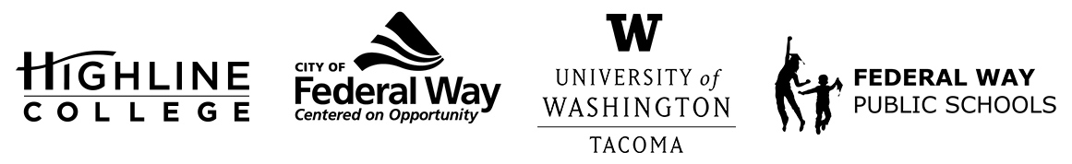
MEDIA RELEASE
FOR RELEASE: Immediately
DATE: April 18, 2022
CONTACT: Highline College: Raechel Dawson; rdawson@highline.edu
University of Washington Tacoma: John Burkhardt; johnbjr@uw.edu
City of Federal Way: Steve McNey; steve.mcney@cityoffederalway.com
Federal Way Public Schools: Whitney Chiang; wchiang@fwps.org

The Hub: Federal Way Higher Education Center to Hold Ribbon Cutting May 13
Celebrate this Milestone with Local Federal Way Leaders
FEDERAL WAY, Wash. — The Hub: Federal Way Higher Education Center will open its doors to the community for a special ribbon-cutting ceremony at 10 a.m., Friday, May 13 to commemorate its opening in 2021. All are welcome to attend.
Speakers will include Highline College President John Mosby, University of Washington Tacoma Chancellor Sheila Edwards Lange, City of Federal Way Mayor Jim Ferrell and Federal Way Public Schools Superintendent Dr. Dani Pfeiffer. Light refreshments and tours of the facility will also be available.

The Hub’s opening in fall 2021 marked a significant milestone for higher education in Federal Way, as visions to bring a higher education facility to Federal Way have been around since 2013.

Beginning Jan. 10, The Hub began offering a variety of classes with more added for spring quarter, which began April 4.

Hybrid courses through Highline College currently include the following: Introduction to Communication, Public Speaking, English and Introduction to Statistics. The hybrid courses take place both at The Hub and online using Canvas. New spring quarter, Highline’s Continuing Education department began offering two courses, Social Security: Your Questions Answered and Healthcare and Your Retirement.

The Hub is also offering three professional development courses for working professionals to gain additional skills and knowledge to impact career success through the University of Washington Tacoma Professional Development Center, which include Project Management, Facilitating Effective Meetings and Organizational Development.

Located at 1615 S. 325th St. in Federal Way, near the Federal Way Driver’s Licensing Office and behind The Commons mall, The Hub is a 7,300-square-foot space with two classrooms, a computer lab, a student study and gathering space, and a reception area. Parking is available for the first 65 attendees.

The Hub is a state-funded higher education center made possible through a partnership between Highline College, the UW Tacoma, the City of Federal Way and Federal Way Public Schools.

For more information about The Hub and to enroll in its courses, visit fwhub.org.

# # #
Attachments: Photo of The Hub: Federal Way Higher Education Center, located at 1615 S. 325th St. in Federal Way.

