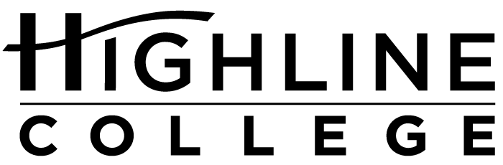

MEDIA RELEASE

FOR RELEASE: Immediately
DATE: April 21, 2016
CONTACT: Adam-Jon Aparicio: (206) 592-3353, aaparicio@highline.edu
Kari Coglon Cantey: (206) 291-8622, kcantey@highline.edu
Dr. Lisa Skari: (206) 870-3705, lskari@highline.edu

From Creativity and Communication to Money and More
Wide range of topics during free Week of Wellness at Highline College

DES MOINES, Wash. — The public is invited to a series of free events during Week of Wellness at Highline College, May 2–5, 2016, designed to promote the importance of emotional and physical health as central to success. United by the theme “Resiliency Through Wellness,” four wellness-themed programs will encourage attendees to live more positive and holistic lives while reducing stress and anxiety. The free lectures and interactive workshops will be led by campus experts.

“The goal is to help students and community members identify what wellness means to them and ways to define wellness despite life’s challenges,” said Adam-Jon Aparicio, who is a faculty counselor in Highline’s Counseling Center and helped establish the program at the college last year.

Week of Wellness is sponsored by Highline’s Counseling Center. All events will be held on the college’s main campus, located midway between Seattle and Tacoma at South 240th Street and Pacific Highway South (Highway 99); address: 2400 S. 240th St., Des Moines, Wash.

For more information, contact Adam-Jon Aparicio: (206) 592-3353 or aaparicio@highline.edu.

Event Schedule:

Monday, May 2, 2016
10:30 a.m.–12 p.m.
“Resiliency and Wellness”
Join associate dean Dr. Allison Lau for a discussion on how to authentically find wellness through resiliency for ourselves as well as the communities we live in.
Building 8, Mt. Constance room

Tuesday, May 3, 2016
11 a.m.–12 p.m.
“Relationship Bootcamp: Loving Yourself and Others”
Looking to better the relationships in your life? Join faculty counselor Joshua Magallanes for a conversation on healthy communication skills that can strength bonds with your loved ones.
Building 8, Inter-Cultural Center

Wednesday, May 4, 2016
11 a.m.–1 p.m.
“Artsy Par-tea!”
Need a moment to pause, reflect and be creative? Join faculty counselors Dr. Gloria Koepping and Thressa Alston for a spot of tea, desserts and guided art.
Building 2

Thursday, May 5, 2016
11 a.m.–12 p.m.
“Retire Like a Bo$$”
Looking for the basics on how to start managing your money? Join faculty counselor Adam-Jon Aparicio for open and honest conversation about money management and budgeting for your goals.
Building 8, Inter-Cultural Center

# # #

Attachment: Photo of Adam-Jon Aparicio

Highline College was founded in 1961 as the first community college in King County. With nearly 17,000 annual students and 350,000 alumni, it is one of the state’s largest institutions of higher education. The college offers a wide range of academic transfer, professional-technical education and bachelor’s degree programs. Alumni include former Seattle Mayor Norm Rice, entrepreneur Junki Yoshida and former Washington state poet laureate Sam Green.

