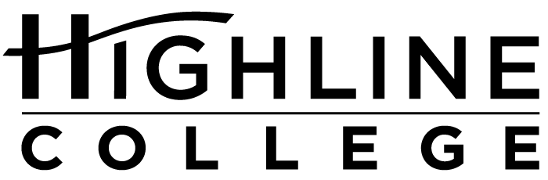

MEDIA RELEASE

FOR RELEASE: Immediately
DATE: April 26, 2016
CONTACT: Rashad C. Norris: (206) 592-3939, rnorris@highline.edu
Kari Coglon Cantey: (206) 291-8622, kcantey@highline.edu
Dr. Lisa Skari: (206) 870-3705, lskari@highline.edu

Highline College to host 3rd annual summit for young women of color
Y.E.L.L. Summit designed for South King County students

DES MOINES, Wash. — Young women of color are invited to Highline College for the Young Educated Ladies Leading (Y.E.L.L.) Summit, a free event designed to empower, encourage and educate. Scheduled for May 14, 2016, the daylong summit is for South King County students in 9th grade and above.

Last year the Y.E.L.L. Summit drew approximately 350 participants. It is free and open to the public, but registration by May 6 is required. Participants will receive giveaways, prizes, breakfast and lunch.

During the summit, which will run from 8:15 a.m. to 4 p.m., attendees can choose from 16 workshops and participate in a leadership activity. Erin Jones, who has been involved in education for the past 24 years, will give the keynote address.

“Erin Jones has seen and experienced inequities in education, not only as a longtime educator, but also as a biracial student while growing up,” said Rashad Norris, who is one of the summit’s organizers and Highline’s Director of Community Engagement. “She is a dynamic speaker whose story will resonate with the young women attending the summit.”

Jones has received several awards during her career, including recognition as a “Champion of Change” at the White House in 2013, during the time she worked for Federal Way Public Schools. She currently serves as director of AVID—or Advancement Via Individual Determination—in the Tacoma School District.

The Y.E.L.L. Summit is patterned after that of Highline’s Black and Brown Male Summit, a popular event each fall for young men of color in South King County.

Like the Black and Brown, the Y.E.L.L. Summit is underwritten by the college and through sponsorships. Norris said the three companies sponsoring this year’s summit—Amerigroup, CyberWatch West and KeyBank—approached the college about being involved.

“They all wanted to be associated with this positive event. We are thrilled and grateful.”

The full schedule and registration information is available at yell.highline.edu.

The summit will be held in Highline’s Student Union (Building 8) on the college’s main campus, located midway between Seattle and Tacoma at South 240th Street and Pacific Highway South (Highway 99).

# # #

Attachment: Photo of Rashad Norris

Highline College was founded in 1961 as the first community college in King County. With nearly 17,000 annual students and 350,000 alumni, it is one of the state’s largest institutions of higher education. The college offers a wide range of academic transfer, professional-technical education and bachelor’s degree programs. Alumni include former Seattle Mayor Norm Rice, entrepreneur Junki Yoshida and former Washington state poet laureate Sam Green.

