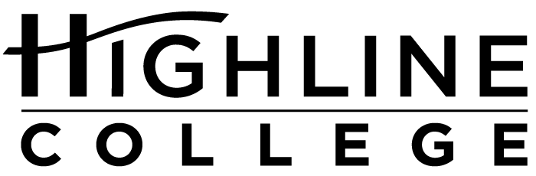

MEDIA RELEASE

FOR RELEASE: Immediately

DATE: April 27, 2017

CONTACT: Tanya Powers: (206) 592-3662, tpowers@highline.edu
Sara Marie Ortiz: (206) 631-3162, sara.ortiz@highlineschools.org
Kari Coglon Cantey: (206) 291-8622, kcantey@highline.edu

Summit Seeks to Support Native Students

Highline College and Highline Public Schools team up for second summit

DES MOINES, Wash. — Approximately 100 high school and college students are expected to attend a summit designed for American Indians and Alaska Natives living in south King County.

Designed to inspire and empower students to be successful in higher education and beyond, the Native Student Success Summit is a collaboration between Highline Public Schools and Highline College. It is scheduled for May 17, 2017, 8:30 a.m.–1 p.m., on Highline College’s main campus.

The summit will include breakout sessions, keynote speakers Swil Kanim (Lummi) and Matt Remle (Standing Rock Lakota) and an elders panel featuring Patsy Whitefoot (Yakama), Jackie Swanson (Muckleshoot) and others.

Sara Marie Ortiz and Tanya Powers are the founders and lead organizers of the summit, which is now in its second year. Participating as presenters and organizers are Native educators, professionals and community leaders from Auburn, Federal Way, Kent, Renton and Seattle School Districts; Green River College; and Seattle Indian Health Board.

“There’s nothing quite like the Native Student Success Summit. We’ve worked hard to create an opportunity that isn’t just about college or career access and success for Native students alone,” said Ortiz, who is a member of Pueblo of Acoma, a tribal community in New Mexico, and manages Highline Public Schools’ Native Education Program.

“We see it as an expansive, immersive, challenging, intergenerational learning opportunity; a chance to connect with each other, ask tough questions, challenge norms, have critical conversations and feel truly supported at the summit and far beyond by a powerful network of Native scholars, professionals, artists, advocates and visionary Native change-makers … this has never been more urgently needed in these very complex times.”

According to Powers, she and Ortiz were inspired by other successful Highline College events for students of color, such as the Black and Brown Male Summit, the Y.E.L.L. Female Summit and the Latinx Summit.

“We are pleased to have this event where we can nurture culture, identity and community,” said Powers, who is mixed heritage St. Lawrence Island/Siberian Yupik and Irish and is the director of Workforce and Baccalaureate Education at Highline College.

The summit is free and open to the public, but registration is required. Registration materials, agenda and list of speakers are available at highline.edu/native-student-summit-2017.

For more information, contact Tanya Powers: tpowers@highline.edu, (206) 592-3662; or Sara Marie Ortiz: sara.ortiz@highlineschools.org, (206) 631-3162.

Highline College is located midway between Seattle and Tacoma at South 240th Street and Pacific Highway South (Highway 99); address: 2400 S. 240th St., Des Moines, Wash.

# # #

Celebrating its 55th anniversary, Highline College was founded in 1961 as the first community college in King County. With nearly 17,000 annual students and 350,000 alumni, it is one of the state’s largest institutions of higher education. The college offers a wide range of academic transfer, professional-technical education and applied bachelor’s degree programs. Alumni include former Seattle Mayor Norm Rice, entrepreneur Junki Yoshida and former Washington state poet laureate Sam Green.

