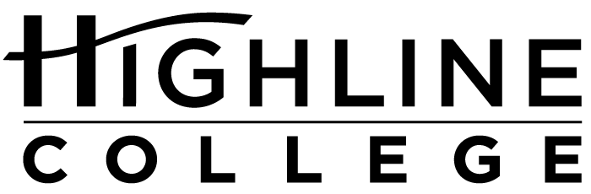

MEDIA RELEASE

FOR RELEASE: Immediately
DATE: April 28, 2016
CONTACT: Jillian Mayer: (941) 321-9430, jmayer@highline.edu
Kari Coglon Cantey: (206) 291-8622, kcantey@highline.edu
Dr. Lisa Skari: (206) 870-3705, lskari@highline.edu

Volunteers Clear Hundreds of Pounds of Debris from Redondo Beach Area
Highline College’s MaST Center organized annual Earth Day event

DES MOINES, Wash. — More than 75 volunteers collected 571.1 pounds of trash and recycling from the roadways and water near Redondo Beach for Earth Day Pier Clear, held on April 23, 2016. Highline College’s Marine Science and Technology (MaST) Center has held the cleanup event for the past three years.

Approximately 20 divers scoured the Redondo dive sites, including areas beneath the public fishing pier and public boat ramp, at depths between 30 and 100 feet, while two safety kayakers patrolled the waters for lift bags full of debris. Underwater conditions were suboptimal for divers.

“Plankton blooms and larvae this time of year made visibility horrible underwater. Luckily, most of us were able to dive below the cloudy layer. You would see piles of trash everywhere,” said Matt Wilson, Highline student and aquarium biologist for the MaST Center.

Meanwhile, more than 50 land-based volunteers cleared the three primary roadways leading to Redondo Beach: Marine View Drive to 16th Avenue, Redondo Way South of 16th Avenue, and Redondo Beach Drive South to 1st Avenue. Walkers worked around construction sites on the Redondo Beach boardwalk with permission from the City of Des Moines.

Other land-based volunteers sorted, counted and weighed debris from the land and water. All debris removed from the Puget Sound was carefully documented. This data will be given to Project AWARE, an international organization that collects data on ocean trash worldwide.

The MaST Center seeks to foster a sense of marine stewardship in students and visitors to the center. While Pier Clear removes several hundred pounds of marine debris, its real value lies in what it teaches volunteers.

“When people become aware of what harm humans cause to our natural environment, they become more vocal about protecting those resources. More than just collecting trash, Pier Clear aims to educate and empower our community to take care of our slice of the Puget Sound,” said Jillian Mayer, AmeriCorps Service Member at the MaST Center and lead organizer of this year’s Pier Clear.

AmeriCorps Service Members at the MaST Center have planned Earth Day Pier Clear three years in a row. In 2014, volunteers collected approximately 600 pounds, and in 2015, around 400 pounds. This year saw a spike in the debris weight, likely owing to the larger number of volunteers this year than in previous years.

This year’s Pier Clear ran from 9 a.m. until 1p.m. Afterward, volunteers enjoyed a potluck-style meal on the MaST Center pier. Information on the MaST Center’s aquarium, programs and volunteer opportunities can be found at mast.highline.edu. It is located at 28203 Redondo Beach Dr. S., Des Moines.

# # #

Attachment: Divers Chris Van Damme, left, and Matt Wilson haul out debris collected from Puget Sound waters off Redondo Beach on April 23 as part of a large volunteer effort during Earth Day Pier Clear. Highline College’s Marine Science and Technology Center, seen in the background, has held the annual cleanup event for the past three years.

Highline College was founded in 1961 as the first community college in King County. With nearly 17,000 annual students and 350,000 alumni, it is one of the state’s largest institutions of higher education. The college offers a wide range of academic transfer, professional-technical education and bachelor’s degree programs. Alumni include former Seattle Mayor Norm Rice, entrepreneur Junki Yoshida and former Washington state poet laureate Sam Green.

