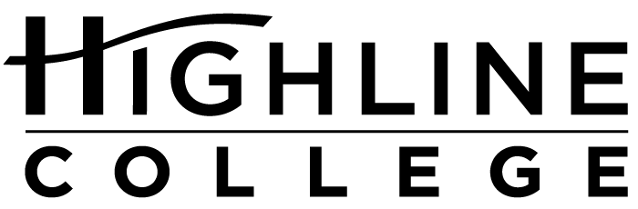

MEDIA RELEASE

FOR RELEASE: Immediately

DATE: May 4, 2017

CONTACT: Laura Rosa: (206) 592-3312, lrosa@highline.edu
LaTonya Brisbane: (206) 592-3312, lbrisbane@highline.edu
Kari Coglon Cantey: (206) 291-8622, kcantey@highline.edu

10 in 10 Challenge Offers Chance to Help College Students

Highline College alumni initiative asks former students to help current ones

DES MOINES, Wash. — A recent text-to-donate push brought in $610 during a 10-day span, bringing Highline College’s Alumni Relations program closer to its $12,840 fundraising goal.

Now with a total of $1,725 in contributions, the program’s leader is pushing for another $11,000 during the next four months. The money will fund 10 student scholarships as part of a 10-month initiative to increase alumni engagement at the college.

According to Laura Rosa, who heads up the program, the initiative — called the T-Bird Alumni 10 in 10 Challenge — targets Highline alumni, asking them to donate a little to make a big difference for current students.

“Even though I’ve been out of college for a number of years, I still remember what a struggle it was to pay for it. I’m sure other alums remember, too,” said Rosa, who is a Highline alum herself, having attended in the late 1980s.

Tuition runs $1,284 a quarter for Washington residents taking a full load, or 15 credits. Even when students receive financial aid to pay for tuition, there are other expenses such as books and fees, she noted.

More than 350,000 people have attended Highline during the past 55 years. Encouraging alumni to donate $10 to support current students could raise more than $3.5 million if everyone participated.

“We realized $3.5 million would be an audacious goal. So, we chose a more reasonable goal of enough to cover one quarter’s worth of tuition for 10 students, which is just under $13,000,” said Rosa.

The monetary goal is the first of a three-pronged goal of the 10 in 10 Challenge. Instead of donating $10, alumni can volunteer 10 hours of time in the community or provide an internship or job shadow opportunity for a Highline student or recent alum.

Practicing what she’s promoting, Rosa is offering an internship in her Alumni Relations program. Highline alumna LaTonya Brisbane has been in the paid position for nearly two quarters now.

“Being an intern has allowed me to apply academic experiences to real world issues and relationship building. I’m able to serve my community while connecting with Highline alumni and supporting current student success,” said Brisbane.

Brisbane earned her associate degree at Highline in 2015 and now is at Evergreen State College pursuing her bachelor’s degree in political economy.

Since it launched in fall of 2016, the 10 in 10 Challenge has posted seven alumni-sponsored internships and shared five volunteer opportunities. The initiative is scheduled to end in August 2017.

Despite its name, the challenge is open to all community members looking to support students, according to Rosa.

More information is available at highline.edu/10-in-10.

# # #

Attachment: Photo of LaTonya Brisbane

Celebrating its 55th anniversary, Highline College was founded in 1961 as the first community college in King County. With nearly 17,000 annual students and 350,000 alumni, it is one of the state’s largest institutions of higher education. The college offers a wide range of academic transfer, professional-technical education and applied bachelor’s degree programs. Alumni include former Seattle Mayor Norm Rice, entrepreneur Junki Yoshida and former Washington state poet laureate Sam Green.

