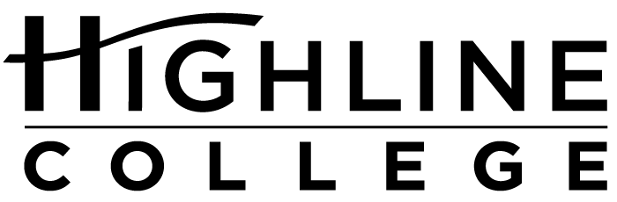

MEDIA RELEASE

FOR RELEASE: Immediately
DATE: May 5, 2016
CONTACT: Tanya Powers: (206) 592-3662, tpowers@highline.edu
Sara Marie Ortiz: (206) 631-3162, sara.ortiz@highlineschools.org
Kari Coglon Cantey: (206) 291-8622, kcantey@highline.edu
Dr. Lisa Skari: (206) 870-3705, lskari@highline.edu

Native Students in South King County Invited to Summit
Highline College to host inaugural summit for Native students in partnership with Highline Public Schools

DES MOINES, Wash. — Native students will have a summit to call their own, thanks to a partnership between Highline Public Schools and Highline College. Designed to inspire and empower high school students from all districts in south King County, the Native Student Success Summit is scheduled for May 18, 2016, 8:30 a.m.–1:30 p.m., on Highline College’s main campus.

The summit for American Indian and Alaska Native students is the result of the work of educators across south King County, spearheaded by Sara Marie Ortiz and Tanya Powers.

Ortiz is a member of Pueblo of Acoma, a tribe in New Mexico, and manages Highline Public Schools’ Native Education Program. Powers is mixed heritage St. Lawrence Island/Siberian Yupik and Irish and is the director of Workforce and Baccalaureate Education at Highline College.

“Last summer, Sara and I brainstormed ways to create community for our youth while honoring their identity and exposing them to college options,” said Powers. “This is what we hope is the first of many such summits.”

According to Powers, the two were inspired by other successful Highline College events for students of color, such as the Black and Brown Male Summit, the Y.E.L.L. Female Summit and the Latino Summit.

Approximately 100 students are expected to attend. The day will include breakout sessions, a college student panel and hands-on activities.

The summit is free and open to the public, but registration is required. Registration materials, agenda and list of speakers are available at highline.edu/native-student-summit-2016.

Highline College is located midway between Seattle and Tacoma at South 240th Street and Pacific Highway South (Highway 99); address: 2400 S. 240th St., Des Moines, Wash.

# # #

Attachment: Photo of Tanya Powers

Highline College was founded in 1961 as the first community college in King County. With nearly 17,000 annual students and 350,000 alumni, it is one of the state’s largest institutions of higher education. The college offers a wide range of academic transfer, professional-technical education and bachelor’s degree programs. Alumni include former Seattle Mayor Norm Rice, entrepreneur Junki Yoshida and former Washington state poet laureate Sam Green.

