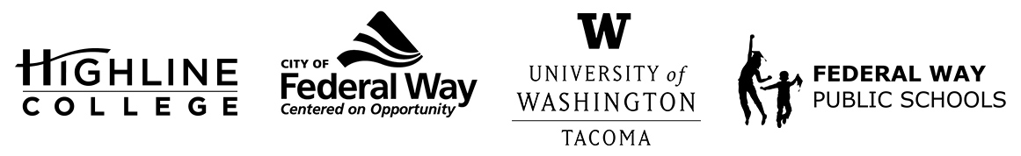
MEDIA RELEASE
FOR RELEASE: Immediately
DATE: June 16, 2021
CONTACT: Highline College: Raechel Dawson; rdawson@highline.edu
University of Washington Tacoma: John Burkhardt; johnbjr@uw.edu
City of Federal Way: Tim Johnson; tim.johnson@cityoffederalway.com
Federal Way Public Schools: Kassie Swenson; kswenson@fwps.org

The Hub: Federal Way Higher Education Center to Open Fall 2021
New site to provide access to adult education, student support services and more
FEDERAL WAY, Wash. — A new higher education facility is coming to Federal Way this fall.
The Hub: Federal Way Higher Education Center, a 7,300-square-foot space, will be located at 1615 S. 325th St. in Federal Way and will feature two classrooms, a computer lab, a student study and gathering place, offices, and a reception area.

Through a partnership with Highline College, the University of Washington Tacoma, the City of Federal Way and Federal Way Public Schools, The Hub will provide access to post-secondary and adult education to the Federal Way community.

Initially, the site will be equipped to offer Highline College student support services, such as general admission, advising, and enrollment help, as well as opportunities to connect with the community, with goals to eventually offer more. In the future, The Hub will offer for-credit coursework; short-term certificate classes in early childhood education, health care and computer science; English language learning and adult education courses; and UW Tacoma professional development coursework.

The facility will open Sept. 27, 2021, and will be staffed from 8 a.m. to 5 p.m., Monday through Friday, following COVID-19 safety guidelines in place at that time, for offering in-person help.

Although hopes to bring a college presence to Federal Way have been around since 2013, it wasn’t until the City of Federal Way launched its University Initiative in 2014 and conducted a higher education needs assessment in 2016 that they determined there was a great need for accessible educational opportunities within the city.

Once the partners signed a memorandum of understanding in 2017 and the project received state funding in 2018, all that was left was to figure out where in Federal Way such a facility could be located before those hopes turned into reality.

The Hub’s site, which is off of Pacific Highway South, is near several restaurants, The Commons mall, the Federal Way Driver’s Licensing Office, and is on a bus line for easy access. And with construction underway for Sound Transit’s Federal Way Link Extension, which will run past Highline College and is scheduled to be complete in 2024, it’s only a matter of time before South King County is more connected to higher education than ever before.

For more information on The Hub, visit fwhub.org.
Quotes:
Highline College President Dr. John Mosby: “We know that Federal Way residents have historically made up a large portion of the Highline College student population. But meeting students where they’re at is vital. Extending our services to Federal Way not only aligns with our mission and values of creating greater educational access and increasing institutional sustainability, but we’ll be better able to serve those who are unable to afford the commute to Des Moines, where Highline College is located. The Hub’s location serves as one less barrier to those seeking a way out of poverty through a college education. And we believe a college education can transform lives. I look forward to opening The Hub in the fall and thank our partners for their incredible work to make this long-held dream a reality.”

University of Washington Tacoma Chancellor Mark Pagano: “We have always seen Federal Way as a valuable partner in our mission to expand access to higher education. That access should not be constrained by municipal boundaries or traffic congestion. The South Sound is emerging as the next hot spot of economic prosperity in the Puget Sound region, and UW Tacoma is proud to work with all our partners to achieve that vibrant future together.”
City of Federal Way Mayor Jim Ferrell: “The opportunity for a center of higher education in Federal Way, which benefits our community, is becoming reality. Education is the great equalizer and the residents/students that will use this center will epitomize this ideal. The University Initiative identified by my administration in 2014 has been achieved.”

Federal Way Public Schools Superintendent Dr. Tammy Campbell: “Federal Way Public Schools is excited to partner on this important endeavor to bring greater access to higher education opportunities to students and families in our community.”

# # #
Attachments: Photo of The Hub: Federal Way Higher Education Center, located at 1615 S. 325th St. in Federal Way. The Hub will open to the community in September 2021.

