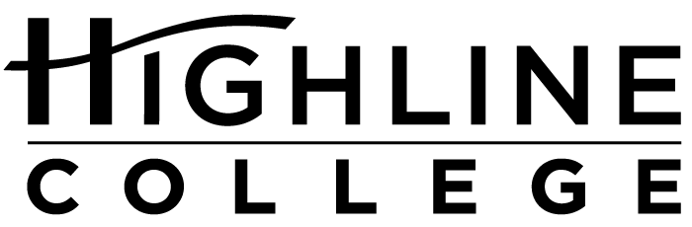

CALENDAR ITEM

FOR RELEASE: Immediately
DATE: June 28, 2016
CONTACT: Chantal Carrancho: (206) 592-4026, ccarrancho@highline.edu
Kari Coglon Cantey: (206) 291-8622, kcantey@highline.edu

Free Job Fair at Highline College
More than 60 employers expected at July 13 event

Event: Highline College Summer Job Fair

Date: Wednesday, July 13, 2016

Time: 11 a.m.–2 p.m.

Price: Free

Location: Highline College’s main campus, Building 8

Highline College’s main campus is located midway between Seattle and Tacoma at South 240th Street and Pacific Highway South (Highway 99); address: 2400 S. 240th St., Des Moines, Wash.

Description: Meet with more than 60 local employers from a wide variety of industries looking to fill full-time, part-time and temporary jobs. The Highline College Summer Job Fair is free and open to the public; no advance registration is necessary. Attendees should be prepared to speak with recruiters, dress professionally and bring extra copies of their resume.

Free career workshops are also available to prepare for the fair. Learn more at highline.edu/calendar.

Participating Employers (partial list):
AAA of Washington
AANAPISI – Highline College
Advanced Health Care
Aegis Living
Aero Controls, Inc.
Aflac
All-Star Auto Glass
Apartment Advantage Staffing
Ashley House
AutoZone
BrightStar Care
Capability Homecare
Comcast
Creative Living Services
Emerald City Medical Staffing, Inc.
Environment Control
Farmers Insurance District Office
Fastenal Company
First Transit
Franciscan Health System
Home Care Referral Registry
InDemand Interpreting
Kent Regional Fire Authority
Korean Women’s Association
Lakeside-Milam Recovery Centers
Life Care Centers of America
Madigan Army Medical Center
McLendon Hardware
New Care Concepts, Inc.
Northwest Hospital & Medical Center
OfficeTeam, Robert Half International
Phoenix Protective Corporation
Port Jobs – Airport Jobs
Renton School District
ResCare Homecare
Ro Health
Seattle Goodwill
Security Industry Specialists, Inc.
Special Care Agency
Think Frink Home Team
U.S. Customs and Border Protection
U.S. Marine Corps
U.S. Senator Patty Murray
Valley Cities Counseling & Consultation
Volt Workforce Solutions
Washington Community Action Network
Washington State Patrol
Wesley Homes
Wyndham Vacation Ownership
Xerox
Xerox – Federal Way

For more information: Visit studentemployment.highline.edu.

# # #

Highline College was founded in 1961 as the first community college in King County. With nearly 17,000 annual students and 350,000 alumni, it is one of the state’s largest institutions of higher education. The college offers a wide range of academic transfer, professional-technical education and bachelor’s degree programs. Alumni include former Seattle Mayor Norm Rice, entrepreneur Junki Yoshida and former Washington state poet laureate Sam Green.

