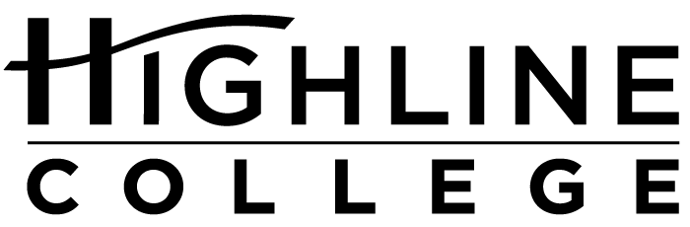

MEDIA RELEASE

FOR RELEASE: Immediately

DATE: August 29, 2017

CONTACT: Dr. Lisa Skari: (206) 592-3705, lskari@highline.edu
Kari Coglon Cantey: (206) 291-8622, kcantey@highline.edu

Presidential Search Process to Begin at Highline College

College’s Board of Trustees Will Hold Special Meeting Aug. 31

DES MOINES, Wash. — The Highline College Board of Trustees will hold a special meeting to consider alternatives for the presidential search process. The meeting is scheduled for Thursday, Aug. 31, 2017, at 1 p.m. in the Library Boardroom (Building 25, 5th floor) on the college’s main campus.

Action may be taken regarding the formation of board member subcommittees.

This will be the board’s first public meeting since July 27, when Dr. Jack Bermingham announced his retirement as Highline’s president.

Bermingham, 68, had been on leave from the college since December 2016 while recovering from open-heart surgery. He had served as president since 2006 and spent 22 years at the college.

The college has enjoyed remarkable leadership stability, with only six presidents during its first 56 years.

Dr. Jeff Wagnitz, Highline’s Vice President for Academic Affairs, is serving as acting president.

Highline’s board is responsible for selecting and employing the college president. It is composed of community members from Highline’s service area of South King County: Dan Altmayer and Bob Roegner, both of Federal Way; Debrena Jackson Gandy, Des Moines; Fred Mendoza, Normandy Park; and Sili Savusa, South Seattle.

Founded in 1961 as the first community college in King County, Highline annually serves approximately 17,000 students, making it one of the state’s largest institutions of higher education.

Highline’s main campus is located midway between Seattle and Tacoma at South 240th Street and Pacific Highway South (Highway 99) in Des Moines.

# # #

With more than 70 percent students of color, Highline College is the most diverse higher education institution in the state, reflecting the diverse and multicultural nature of the communities it serves. The college offers a wide range of academic transfer, professional-technical education, basic skills and applied bachelor’s degree programs. Alumni include former Seattle Mayor Norm Rice, entrepreneur Junki Yoshida and former Washington state poet laureate Sam Green.

