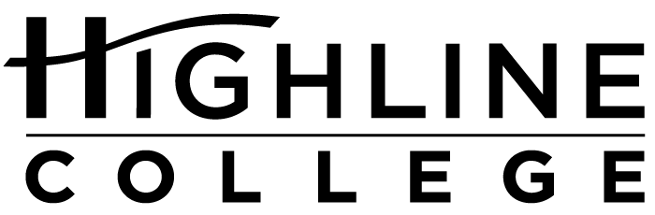

MEDIA RELEASE

FOR RELEASE: Immediately

DATE: September 24, 2018

CONTACT: Doris Martinez: (206) 592-4319, dmartinez@highline.edu
Angie Hunckler: (206) 592-4036, ahunckler@highline.edu
Kari Coglon Cantey: (206) 291-8622, kcantey@highline.edu

LGBTQIA Week Provides Support, Raises Awareness at Highline

Resource Fair Features Over 50 Community Organizations and On-Campus Services

DES MOINES, Wash. — The public is invited to Highline College for a weeklong series of free events and activities exploring LGBTQIA identity and social justice issues. The series will run Oct. 8–12, 2018, on the college’s main campus.

Scheduled to coincide with National Coming Out Day (Oct. 11), LGBTQIA Week also serves to celebrate and remember the history of the gay rights movement.

Full descriptions are at LGBTQIA Week 2018.

Monday, Oct. 8
11 a.m.–12:30 p.m.
Building 7
“Islamahomophobia: Why Visibility Matters” presented by Sonj Basha
One of the most powerful tools of oppression is division. How can the queer community become stronger by bringing parts of itself closer together? Hear from Sonj Basha, who is queer and Muslim, as she discusses fighting for justice at the intersections of identities.

Tuesday, Oct. 9
9–10:30 a.m.
Building 7
“Queer and Trans Health” presented by Dr. Elizabeth Eaman
Dr. Elizabeth Eaman will discuss queer and transgender health, pulling from her experience specializing in the primary care of transgender, non-binary and LGB patients. Since 2003, she has worked with various organizations and educational institutions to improve LGBT+ patient care.

11 a.m.–1 p.m.
Building 8
“BB!: Ballroom Basics, Recentering QTPOC Movement Resistance History” presented by Angel ‘Moonyeka’ Alviar-Langley and Mikey Xi
How is vogue and ballroom dancing related? Presenters Angel ‘Moonyeka’ Alviar-Langley and Mikey Xi will explore the origins of voguing and the influence it has had on the LGBTQ culture. Attendees will view clips from films including “Paris Is Burning,” a prize-winning 1990 documentary about the dance.

Wednesday, Oct. 10
9–10:30 a.m.
Building 7
“De-Whitening LGBT Experience” presented by Whitney Archer
Hear from Whitney Archer in “De-Whitening LGBT Experience.” Archer directs the Hattie Redmond Women & Gender Center at Oregon State University where she is also pursuing a Ph.D. in women, gender and sexuality studies.

Thursday, Oct. 11
11 a.m.–1 p.m.
Building 8
Resource Fair and Entertainment
Visitors can explore campus and community resources during the 2018 Resource Fair. More than 50 community organizations and Highline programs and services will provide information to support the health and wellness of the LGBTQ community. DJ Phenohype (Allison Masangkay) will provide entertainment.

Friday, Oct. 12
10–11:30 a.m.
Building 2
“LGBTQIAA 101 Workshop” presented by Dennis Denman
The LGBTQIAA 101 workshop will bring community members together in a safe and shared space to discuss terms and issues that arise in the LGBTQ+ community. Presenter Dennis Denman will cover topics such as allyship (and how to be a good one) and intersectionality (we’re not all white).

# # #

Photo caption: The Highline Student Union will be the site of the second annual Resource Fair, where more than 50 on- and off-campus groups and organizations will offer information during the college’s annual LGBTQIA Week, Oct. 8–12.

Links within this release:
- Highline College location and directions: https://www.highline.edu/campus-guide/locations-and-directions/
- National Coming Out Day: https://en.wikipedia.org/wiki/National_Coming_Out_Day
- Highline College LGBTQIA Week 2018: https://lgbtqia.highline.edu/events/

Founded in 1961 as the first community college in King County, Highline College annually serves approximately 17,000 students. With more than 70 percent students of color, Highline is the most diverse higher education institution in the state. The college offers a wide range of academic transfer, professional-technical education, basic skills and applied bachelor’s degree programs. Alumni include former Seattle Mayor Norm Rice, entrepreneur Junki Yoshida and former Washington state poet laureate Sam Green.

