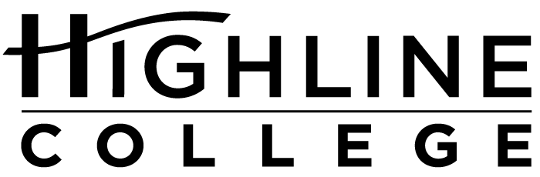

MEDIA RELEASE

FOR RELEASE: Immediately

DATE: September 25, 2017

CONTACT: Dominique Austin: (206) 592-3256, daustin@highline.edu
Angie Hunckler: (206) 592-4036, ahunckler@highline.edu
Kari Coglon Cantey: (206) 291-8622, kcantey@highline.edu

LGBTQIA Week at Highline to Raise Awareness, Support

College’s First Resource Fair Features Over 40 Booths

DES MOINES, Wash. — The public is invited to Highline College for a weeklong series of educational events and activities exploring LGBTQIA identity and social justice issues. The series will run Oct. 9–13, 2017, on the college’s main campus, with a new resource fair Oct. 11.

Scheduled to coincide with National Coming Out Day (Oct. 11), LGBTQIA Week celebrates and remembers the history of the gay rights movement. Events are free and open to all.

Monday, Oct. 9, 11 a.m.–12:30 p.m.
“En-storying Resistance” presented by Dr. Qwo-Li Driskill
Building 7
Description: Using poetry, history and personal story, Driskill will address how by telling their stories, indigenous and LGBTQIA peoples can contribute to social transformation, resistance, healing and imaginings of a decolonized future.

Tuesday, Oct. 10, 12–1:30 p.m.
PFLAG Panel and Discussion
Building 8, Mt. Constance Room
Description: Coming out can be challenging for anyone who identifies as lesbian, gay, bisexual, transgender or queer. PFLAG Tacoma members will talk about their experiences with the coming out process. PFLAG is a volunteer organization with a mission to meet people where they are and to collaborate with others

Wednesday, Oct. 11, 12–2 p.m.
LGBTQIA Resource Fair and Entertainment
Building 8
Description: Highline and its community partners support the health and wellness of the LGBTQ community. In the first resource fair of its kind at the college, visitors can explore more than 40 campus and community resources to connect with caring and affirming resources. Entertainment provided by DJ Reverend Dollars, aka Renee Jarreau Greene.

Thursday, Oct. 12, 1:30–3 p.m.
“Fight to Win! Critical Trans Resistance in Scary Times” presented by Dean Spade
Building 7
Description: In his talk, Spade will raise questions about how increased mainstream visibility of trans people relates to on-the-ground struggles for trans survival.

Friday, Oct. 13, 9–10:30 a.m.
“Butterfly: Una Transformacion, Una Ascencion” presented by Syd Emmanuel Arrojo
Building 25, Room 608
Description: A multi-talented artist, Syd Emmanuel Arrojo will share creativity through spoken word art, creative writing, colorful sketches, vocal performance and wooden instruments.

Full event descriptions are at LGBTQIA Week 2017.

# # #

Links within this release:
- Highline College location and directions: https://www.highline.edu/campus-guide/locations-and-directions/
- Highline College LGBTQIA Week 2017: https://lgbtqia.highline.edu/events/

Founded in 1961 as the first community college in King County, Highline College annually serves approximately 17,000 students. With more than 70 percent students of color, Highline is the most diverse higher education institution in the state. The college offers a wide range of academic transfer, professional-technical education, basic skills and applied bachelor’s degree programs. Alumni include former Seattle Mayor Norm Rice, entrepreneur Junki Yoshida and former Washington state poet laureate Sam Green.

