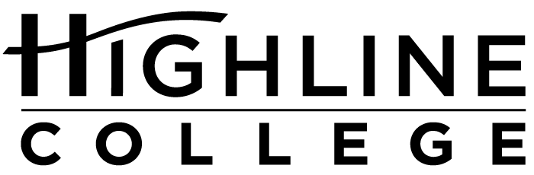

MEDIA RELEASE

FOR RELEASE: Immediately
DATE: September 29, 2016
CONTACT: Doris Martinez: (206) 592-4319, dmartinez@highline.edu
Kari Coglon Cantey: (206) 291-8622, kcantey@highline.edu

‘The Politics of Pee’ Kicks Off LGBTQIA Month at Highline
Free events invite public to explore LGBTQIA issues

DES MOINES, Wash. — LGBTQIA Month at Highline College will include free workshops, discussions and a documentary exploring homeless LGBT youth. United by the theme “Our History Is Now,” the October events coincide with National Coming Out Day (October 11). The goal of LGBTQIA Month is to actively promote and support a learning environment that ensures social justice, mutual respect, understanding, civility and non-violence.

All events are free and open to the public and will be held on the college’s main campus, located midway between Seattle and Tacoma at South 240th Street and Pacific Highway South (Highway 99); address: 2400 S. 240th St., Des Moines, Wash.

October 4, 11 a.m.–12 p.m.
“The Politics of Pee” presented by T.J. Jourian
Building 8, Mt. Constance room
Description: The past year has been stained by widespread legislative backlash against the rising visibility of the transgender community, most notorious among them being North Carolina's House Bill 2 (HB2). But why do people care so much about which restroom transgender people use? In “The Politics of Pee,” Jourian will discuss moral panics, the limitations of law and the administrative violence that impacts transgender people.

October 4, 12–1 p.m.
LGBTQIA Social
Building 8, Mt. Constance room
Description: Following “The Politics of Pee,” come to Highline’s annual LGBTQIA Social to talk with T.J. Jourian and meet others from the LGBTQIA community.

October 11, 10–10:50 a.m.
National Coming Out Day with Parents and Family of Lesbians and Gays (PFLAG)
Building 8, Mt. Constance room
Description: Coming out can be challenging for anyone who identifies as lesbian, gay, bisexual, transgender or queer. For national coming out day, Highline will have panelists from PFLAG who will talk about their experiences with the coming out process. PFLAG is a volunteer organization whose mission is to meet people where they are and collaborate with others. PFLAG envisions a world where diversity is celebrated and all people are respected, valued and affirmed inclusive of their sexual orientation, gender identity and gender expression.

October 25, 1–3 p.m.
Safe Zones Training for Students, Part 1
Building 8, Mt. Skokomish room
Description: Safe Zones is Highline College’s peer-led LGBTQIA inclusivity training program. This workshop will present the first of a two-part training. While this particular training is designed for students, all participants are welcome and will learn more about the queer community as well as build skills to use in the classroom, workplace and community.

October 26, 1:30–3 p.m.
“Queer Homeless Youth: A Road to Home” documentary
Building 8, Mt. Constance room
Description: Walking to Penn Station to visit family in New Jersey, Cal Skaggs always saw groups of teenagers hanging around. Armed with backpacks and wandering around seemingly aimlessly, Skaggs wondered what their story was. The answer came in 2012 when he saw an interview on a local cable station with Carl Siciliano, the founder of the Ali Forney Center (AFC), a homeless shelter for young LGBT people. He explained that New York City alone has more than 40,000 homeless kids — a large percentage of them are LGBT. “A Road to Home” is the story of six young people and the AFC, which is working to protect LGBTQ youths from the harms of homelessness and empower them with tools to live independently.

# # #

Celebrating its 55th anniversary, Highline College was founded in 1961 as the first community college in King County. With nearly 17,000 annual students and 350,000 alumni, it is one of the state’s largest institutions of higher education. The college offers a wide range of academic transfer, professional-technical education and applied bachelor’s degree programs. Alumni include former Seattle Mayor Norm Rice, entrepreneur Junki Yoshida and former Washington state poet laureate Sam Green.

