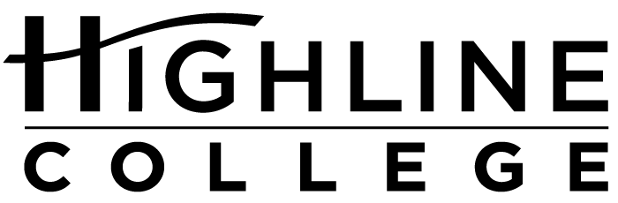

MEDIA RELEASE

FOR RELEASE: Immediately

DATE: October 4, 2017

CONTACT: Tanya Powers: (206) 592-3662, tpowers@highline.edu
Kari Coglon Cantey: (206) 291-8622, kcantey@highline.edu

2nd Annual Indigenous Peoples Day at Highline

Two Speakers Featured at Free Event

DES MOINES, Wash. — The public is invited to recognize Indigenous Peoples Day on October 9, 2017, at Highline College. Two Native presenters will offer their unique perspectives. Both talks are free and open to all on the college’s main campus.

Highline began official recognition of the day in 2016. The day offers an opportunity both to reflect upon the ongoing struggles of indigenous peoples and to celebrate the thriving culture and value that neighboring tribes, including Muckleshoot, Puyallup, Duwamish and other indigenous nations, add to the college.

Find full event descriptions at Indigenous Peoples Day 2017.

10–11 a.m.
“Indigenous Peoples in 2017” presented by Dr. Denise Bill
Building 2
Description: Bills will share what Indigenous Peoples Day means to indigenous peoples. Attendees will learn about the Muckleshoot Indian Tribe and some of its programs: higher education, language, art, history and land.

11 a.m.–12:30 p.m.
“En-storying Resistance” presented by Dr. Qwo-Li Driskill
Building 7
Description: Using poetry, history and personal story, Driskill will address how by telling their stories, indigenous and LGBTQ+ peoples can contribute to social transformation, resistance, healing and imaginings of a decolonized future. Driskill's talk is presented in partnership with LGBTQIA Week.

# # #

Links within this release:
- Highline College location and directions: https://www.highline.edu/campus-guide/locations-and-directions/
- Indigenous Peoples Day 2017: https://www.highline.edu/indigenous-peoples-day-2017/
- Highline College LGBTQIA Week 2017: https://lgbtqia.highline.edu/events/

Founded in 1961 as the first community college in King County, Highline College annually serves approximately 17,000 students. With more than 70 percent students of color, Highline is the most diverse higher education institution in the state. The college offers a wide range of academic transfer, professional-technical education, basic skills and applied bachelor’s degree programs. Alumni include former Seattle Mayor Norm Rice, entrepreneur Junki Yoshida and former Washington state poet laureate Sam Green.

