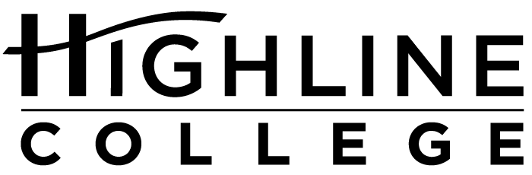

MEDIA RELEASE

FOR RELEASE: Immediately

DATE: October 9, 2017

CONTACT: Chantal Carrancho: (206) 592-4026, ccarrancho@highline.edu
Kari Coglon Cantey: (206) 291-8622, kcantey@highline.edu

Free Job Fair at Highline College

Nearly 60 Employers Expected at Oct. 18 Event

DES MOINES, Wash. — Close to 60 local employers with full-time, part-time and temporary job opening will be represented at Highline College’s Fall Job Fair. The event is free and open to the public; no advance registration is necessary.

Date: Wednesday, October 18, 2017
Time: 10 a.m.–1 p.m.
Location: Highline College’s main campus, Building 8
Cost: Free for job seekers
Information: View the latest list of participating employers.

Employers from a wide variety of industries will be represented. Attendees should be prepared to speak with recruiters, dress professionally and bring extra copies of their résumé.

Free career workshops are also available to prepare for the fair.

Participating Employers:
ABM Healthcare Support Services
Amazon Fulfillment
American Family Insurance
Apartment Advantage Staffing
Apple Retail
AT&T Retail
BECU
Bellair Charters
Big 5 Sporting Goods
Bright Horizons
CarMax
City of SeaTac
College Nannies & Tutors
Columbia Hospitality, Inc.
Comcast
Compass Housing Alliance
Downtown Emergency Service Center
Family Resource Home Care
Fastenal Company
Federal Way Public Schools
FedEx Express
FedEx Ground
First Student
Franciscan Health System
Full Life Care
Grace Children’s Center
Harris Rebar
Highline College’s Community & Employment Services
Highline Public Schools
Home Care Referral Registry
Kelly Services
KinderCare
Korean Women’s Association
Lakeside-Milam Recovery Centers
Macy’s
Northwest Hospital & Medical Center
Ontrac
Overlake Hospital Medical Center
Overlake Terrace
Phoenix Protective Corporation
PhysAssist Scribes, Inc.
Port Jobs – Airport Jobs
Primerica
Prologistix
Puget Sound Regional Services
Renton School District
Rescare
Sears Holdings Corporation
Select Staffing
UPS
U.S. Army Recruiting Station
U.S. Navy Careers
Uwajimaya
Valley Cities Counseling & Consultation
Washington Community Action Network
YMCA of Greater Seattle

# # #

Links within this release:
- Highline College’s main campus: https://www.highline.edu/campus-guide/locations-and-directions/
- Free career workshops: https://studentemployment.highline.edu/events/
- Participating employers: https://studentemployment.highline.edu/fall-job-fair-employers/

Founded in 1961 as the first community college in King County, Highline College annually serves approximately 17,000 students. With more than 70 percent students of color, Highline is the most diverse higher education institution in the state. The college offers a wide range of academic transfer, professional-technical education, basic skills and applied bachelor’s degree programs. Alumni include former Seattle Mayor Norm Rice, entrepreneur Junki Yoshida and former Washington state poet laureate Sam Green.

