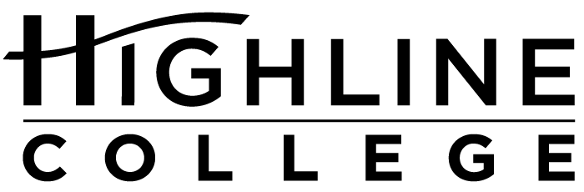

MEDIA RELEASE

FOR RELEASE: Immediately

DATE: October 19, 2017

CONTACT: Garick Sherburn: (206) 592-4677, gsherburn@highline.edu
Kari Coglon Cantey: (206) 291-8622, kcantey@highline.edu

Highline Student, Social Justice Advocate to Headline Oct. 26 Event

Free Event Marks Disability Awareness Month at College

DES MOINES, Wash. — The public is invited to hear student Helen Nash present “The Intersections of Inclusion” on Oct. 26, 2017, 11 a.m.–12:30 p.m., at Highline College (main campus, Building 2). She will talk about her experiences with intersectionality and disability. Her talk will be followed by a roundtable discussion on equity, diversity, disability and inclusion.

The free event is part of the college’s annual celebration of Disability Awareness Month. It is open to all; no reservation is required.

Nash, who is enrolled in Highline’s ACHIEVE Program, is a passionate social justice advocate with Down syndrome. She graduated from Nathan Hale High School, where she participated on the swim team and in the Pride Club and Unified Drama. Nash is also active on the Skihawks Racing Team and Special Olympics Unified Sports teams.

# # #

Attachment:
Helen Nash poses with Garrison Titan earlier this month at the Puget Sound Buddy Walk, an annual event that raises awareness and funds to benefit individuals with Down syndrome and their families. Nash gave a talk at the Oct. 1 event, which also featured Garrison Titan, a volunteer organization whose members dress as Star Wars characters to support charity events.

Link within this release:
Highline College location and directions: https://www.highline.edu/campus-guide/locations-and-directions/
ACHIEVE Program: https://achieve.highline.edu/
Skihawks Racing Team: http://www.skihawksracing.org/
Special Olympics Unified Sports: http://specialolympicswashington.org/unified/
Puget Sound Buddy Walk: http://downsyndromecommunity.org/puget-sound-buddy-walk/
Garrison Titan: http://garrisontitan.com

Founded in 1961 as the first community college in King County, Highline College annually serves more than 17,000 students. With over 70 percent students of color, Highline is the most diverse higher education institution in the state. The college offers a wide range of academic transfer, professional-technical education, basic skills and applied bachelor’s degree programs. Alumni include former Seattle Mayor Norm Rice, entrepreneur Junki Yoshida and former Washington state poet laureate Sam Green.

