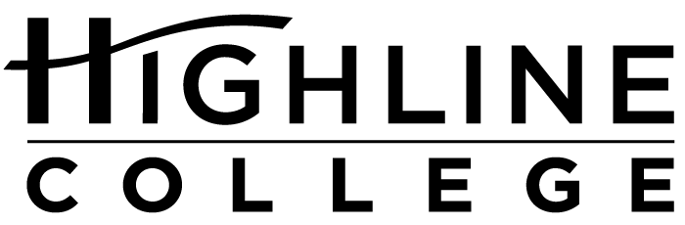

MEDIA RELEASE

FOR RELEASE: Immediately
DATE: November 1, 2016
CONTACT: Kari Coglon Cantey: (206) 291-8622, kcantey@highline.edu

Four-Time Winner of National Diversity Award
Highline College is only community college in state to be recognized for excellence

DES MOINES, Wash. — For the fourth consecutive year, Highline College has received the Higher Education Excellence in Diversity (HEED) Award, a national honor recognizing U.S. colleges and universities that demonstrate an outstanding commitment to diversity and inclusion. Highline was one of only two institutions in Washington — the other being Whitworth University — and one of only nine community colleges nationwide to receive the 2016 award.

Given by Insight Into Diversity magazine, the HEED Award is presented annually to institutions demonstrating initiatives that embrace all aspects of diversity, including gender, race, ethnicity, veterans, people with disabilities and members of the LGBTQ community.

“While we look at numbers and expect continued improvement for those schools that receive the HEED Award year after year, we also use a holistic approach in reviewing each application. Our standards are high, and we look for institutions where diversity and inclusion are woven into the work being accomplished every day across their campus,” said Lenore Pearlstein, publisher of Insight Into Diversity magazine, the oldest and largest diversity-focused publication in higher education.

With more than 70 percent students of color and people representing more than 120 cultures, Highline is the most racially and ethnically diverse institution of higher education in Washington. Highline has won a number of awards of late, giving the college national recognition as a leader among the nation’s community colleges for advancing educational equity and social justice.

“We have enjoyed extraordinary recognitions from Insight Into Diversity and other organizations in recent years reflecting our innovative initiatives that improve student success and engage our communities. I hope that this wonderful award enhances the pride that our students feel about the quality of their own educational accomplishments,” said Dr. Jack Bermingham, Highline’s president.

As a recipient of the 2016 HEED Award, Highline is featured in the magazine’s November 2016 issue, along with the 82 other recipients:

Anne Arundel Community College
Arizona Summit Law School
Augusta University
Ball State University
California State University, East Bay
California State University, Fresno
California State University, Northridge
California State University, San Marcos
Capital Community College
Case Western Reserve University
Central Michigan University
Cleveland State University
Columbia University in the City of New York
Cuyahoga Community College
Davenport University
DePaul University
East Carolina University
Eastern Kentucky University
Edinboro University of Pennsylvania
El Paso County Community College District
Florida Coastal School of Law
Florida State University
Framingham State University
Georgia Institute of Technology
Georgia State University
Grossmont-Cuyamaca Community College District
Houston Community College
Indiana University-Bloomington
Indiana University-Purdue University Indianapolis
Kansas State University
Kennesaw State University
Kent State University
Louisiana State University and Agricultural and Mechanical College
Metropolitan State University of Denver
Miami Dade College
Millersville University
Northeastern University
Northern Arizona University
Northern Virginia Community College
Oklahoma State University
Pennsylvania State University, The
Rochester Institute of Technology
Saint Louis University
San Diego State University
School of the Art Institute of Chicago
Seminole State College of Florida
Southern Illinois University Edwardsville
Southwestern Law School
St. Cloud State University
Stockton University
SUNY Buffalo State College
SUNY System Administration
Texas Tech University
Union College in New York
University of Alabama at Birmingham
University of Central Florida
University of Cincinnati
University of Colorado Boulder
University of Georgia
University of Houston
University of Houston Law Center
University of Illinois at Chicago
University of Illinois at Urbana-Champaign
University of Louisville
University of Maryland University College
University of Massachusetts Boston
University of Massachusetts Lowell
University of Minnesota-Twin Cities
University of North Carolina at Chapel Hill
University of North Florida
University of Oklahoma
University of South Carolina
University of Texas at Austin, The
University of Toledo, The
University of Vermont
University of Virginia
University of West Florida
Virginia Polytechnic Institute and State University
West Virginia University
Western Michigan University
Whitworth University
Widener University

For more information about the 2016 HEED Award, visit insightintodiversity.com. To learn more about Highline and its commitment to diversity and inclusion, visit highline.edu/about-us.

# # #

Attachment: Photo of Dr. Jack Bermingham

Celebrating its 55th anniversary, Highline College was founded in 1961 as the first community college in King County. With nearly 17,000 annual students and 350,000 alumni, it is one of the state’s largest institutions of higher education. The college offers a wide range of academic transfer, professional-technical education and applied bachelor’s degree programs. Alumni include former Seattle Mayor Norm Rice, entrepreneur Junki Yoshida and former Washington state poet laureate Sam Green.

