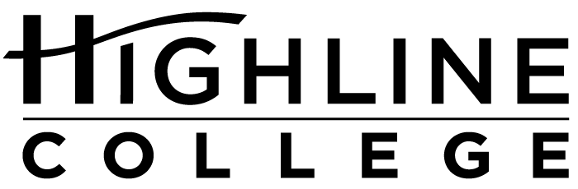

MEDIA RELEASE

FOR RELEASE: Immediately

DATE: November 27, 2017

CONTACT: Dr. Patti Rosendahl: (206) 592-3200, prosendahl@highline.edu
Kari Coglon Cantey: (206) 291-8622, kcantey@highline.edu

Listening Sessions Planned for Highline’s Presidential Search

Public Invited to Sessions Across South King County

DES MOINES, Wash. — As part of its presidential search process, Highline College trustees will hold several listening sessions to learn what community members are looking for in the college’s next leader.

Sessions are scheduled in several locations throughout South King County and are open to all:
— Dec. 4, 6:30 p.m.: Wiley Center Neighborhood House at Greenbridge
— Dec. 6, daytime sessions: Highline College main campus, Building 2 (times will be posted at highline.edu/presidential-search-listening-sessions once they are available)
— Dec. 11, 6:30 p.m.: Federal Way Library, Meeting Room 2

Trustees will use what they learn at the sessions to help create the presidential profile. Profiles often outline general duties and desired qualities or characteristics.

Highline’s board is responsible for selecting and employing the college president. It is composed of community members from Highline’s service area of South King County: Dan Altmayer and Bob Roegner, both of Federal Way; Debrena Jackson Gandy, Des Moines; Fred Mendoza, Normandy Park; and Sili Savusa, White Center.

To learn what has happened to date in the search for Highline’s next leader, visit the Presidential Search news page.

# # #

Links within this release:
- Highline College Board of Trustees: https://www.highline.edu/about-us/board-of-trustees/
- Wiley Center Neighborhood House at Greenbridge: http://www.nhwa.org/contactus/location.php?location=3
- Highline College’s main campus: https://www.highline.edu/campus-guide/locations-and-directions/
- Listening sessions: https://www.highline.edu/presidential-search-listening-sessions/
- Federal Way Library: https://kcls.org/locations/1509/
- Presidential Search news page: https://www.highline.edu/category/presidential-search/

Founded in 1961 as the first community college in King County, Highline College annually serves more than 17,000 students. With over 70 percent students of color, Highline is the most diverse higher education institution in the state. The college offers a wide range of academic transfer, professional-technical education, basic skills and applied bachelor’s degree programs. Alumni include former Seattle Mayor Norm Rice, entrepreneur Junki Yoshida and former Washington state poet laureate Sam Green.

