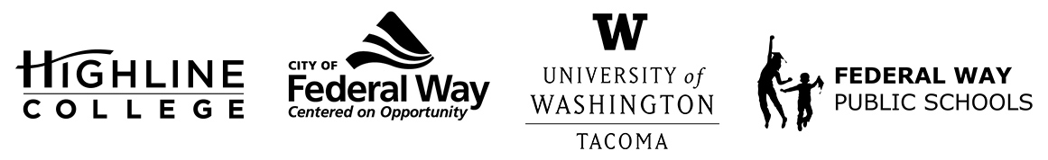
MEDIA RELEASE
FOR RELEASE: Immediately
DATE: Dec. 15, 2021
CONTACT: Highline College: Raechel Dawson; rdawson@highline.edu
University of Washington Tacoma: John Burkhardt; johnbjr@uw.edu
City of Federal Way: Tim Johnson; tim.johnson@cityoffederalway.com
Federal Way Public Schools: Whitney Chiang; wchiang@fwps.org

The Hub: Federal Way Higher Education Center to Hold Public Tours Jan. 7
Free Dick’s Burgers for First 50 Attendees
FEDERAL WAY, Wash. — The Hub: Federal Way Higher Education Center will open its doors to the community for public tours from 1-3:30 p.m. on Friday, Jan. 7, 2022. All are welcome, however, COVID-19 vaccination verification and masks are required for entry.
The first 50 tour participants will receive a free Dick’s burger, and all attendees will receive a swag bag. The swag bag will include items promoting The Hub and its partners.

The Hub’s opening in fall 2021 marked a significant milestone for higher education in Federal Way, as hopes to bring a higher education facility to Federal Way have been around since 2013.

Beginning Jan. 10, 2022, The Hub is prepared to offer a variety of classes.

Hybrid courses through Highline College will include an English class, Introduction to Communications, Public Speaking, Introduction to Statistics. The hybrid courses will take place both at The Hub and online using Canvas. The courses are open for enrollment now through Jan. 12, 2022.

The Hub will also offer two instances of an in-person Project Management course through the University of Washington Tacoma Professional Development Center, beginning Jan. 26, 2022 and, again April 6, 2022.

Located at 1615 S. 325th St. in Federal Way, near the Federal Way Driver’s Licensing Office and behind The Commons mall, The Hub is a 7,300-square-foot space with two classrooms, a computer lab, a student study and gathering space, and a reception area.

The Hub is a state-funded higher education center made possible through a partnership between Highline College, the UW Tacoma, the City of Federal Way and Federal Way Public Schools.

For more information about The Hub and to enroll in its courses, visit fwhub.org.

# # #

